OOI Data Explorer Pioneer MAB Web Quest
Prepared for the 2025 OOI Data Labs Pedagogy Workshop

This Web Quest is intended for participants to gain familiarity with:
- OOI infrastructure as listed in Data Explorer,
- OOI Data Explorer as a tool,
- OOI Data Access as provided by Data Explorer.
The main goal of the Quest is for participants to share their own Data View (step 7).

We will start with a Data View that has already been created showing dissolved oxygen and salinity on the seafloor of the Pioneer MAB Southern Surface Mooring.
- https://dataexplorer.oceanobservatories.org/?ls=xKnA_DDf#add-data-view/BkkFlJdB/1

Navigating OOI Infrastructure in a Data View
Click on the title (topmost line) to open one of the Saved charts (on the right) in the Data View linked above.
- 1. Note that the title of the Data chart has 4 labels, each with a drop-down arrow. These are organized by: Array / Platform / Node: Instrument / Parameter.
Which Data chart did you select? [Paste the full title.]

- 2. To see the geographic position of this Platform within the Array, click open the Array label (Coastal Pioneer MAB Array) and hover over your Platform in the list of Platforms.
Identify another Platform to explore later in step 6 to see how the sites compare.

- 3. Use the browser back arrow to go back to the Data chart you opened in Step 1. (Or navigate into your Platform, then Node, then Instrument, then Parameter.) Some instruments have multiple parameters that can be plotted. If available, click the drop-down list to open another parameter to compare to the DO and salinity we already have selected.
Which Parameter did you select? [Paste the URL from your browser window to save what you are looking at.]

- 4. Click on the tab for “More information” (next to the Data tab).
What kinds of information can you learn about the Instrument and Parameter(s) on this page?

- 5. Bonus: What is the reference designator listed near the bottom of the “More information” tab?
This dataset ID is handy when using Python, R, JupyterHub or other tools to download data programmatically from the OOI ERDDAP data.

Adding charts to a Data View
Note: For more help using the Data Explorer, click the “Help” button in the upper right to access the interactive guide, extensive documentation, or support forum. You can also check out these step-by-step video tutorials.

Next, let’s find & visualize data from another Platform to see how it compares. (Alternatively, you can choose the same platform but a different instrument, like you did in Step 3.)

- 6. In the title of your Data chart, use the drop-down arrow next to the Platform name, and open the alternate Platform you identified in step 2. Next, choose a Node type and then open the Parameter pulldown to select a parameter you’re interested in. Click to open its Data chart.
Describe any patterns in the graph you see that are interesting to you. Make sure you’re looking at the same time range: April 2025. [Paste the URL from your browser window to save what you are looking at.]

Now let’s compare your selected Parameter to the others in the Data View linked above.

Note, if your new dataset is from an instrument on a Wire-Following Profiler: congrats, you already did Bonus step 9 below. While you can save these instruments to a Data View, you cannot add them to a Comparison Chart. Instead, please find a Parameter at fixed depth (or height), for example, the Parameter that you selected in step 3 above.

- 7. When you have a Data chart open for a fixed depth (or height) time-series, you can add it to a Comparison Chart using the following steps.
  - click the star upper right,
  - check the box Save to data view,
  - then check the box Add to compare chart,
  - then click the label to open the Data View.

You should see your Parameter added as a new plot to the Comparison Chart.

To share your updated Data View, you can create a link by clicking the link icon as shown in the screenshot below. [Paste the URL from the “Share data view” pop-up.]
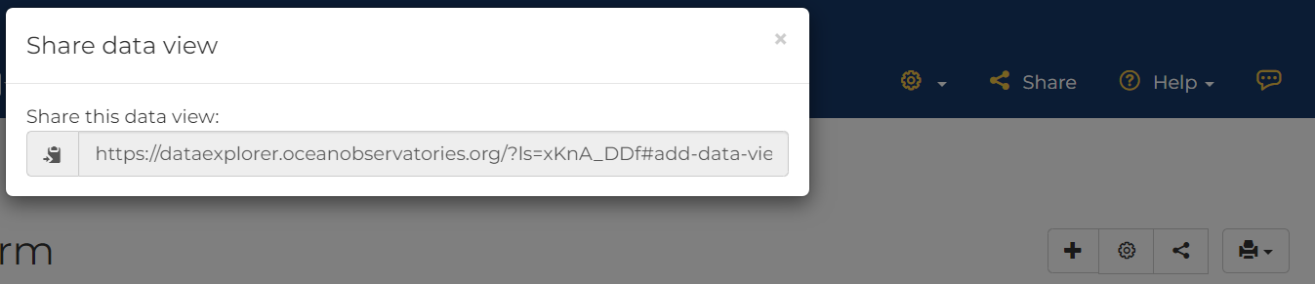

Bonus: You can use the Annotations feature to find out more about any issues identified as part of the human-in-the-loop (HITL) quality control (QC) process.
- 8. Open a Data chart. Click on the tab “Annotations list” (next to the “More information” tab). If you notice a gap or something strange in the data, this is where you would first look to see if the OOI Data Team has already made a note.

Bonus: Find & visualize profiler data
- 9. If you have not already done so, navigate into a Profiler Mooring Platform, select the Wire-Following Profiler Node, and open and explore a profiler Data chart.

Note, the data portal also includes data from underwater gliders. Their data plots look very similar to wire-following profiler plots, but obviously you need to consider how the glider moves over time. A glider dataset page includes a map and a 3D visualization, in addition to the transect timeseries visualization.

Downloading OOI Data from the Data Explorer
Let’s download a quick CSV file for a timeseries dataset.
  - Open a Data chart and click on the green Downloads button to open a pop-up.
  - Note there are 3 sections to this pop-up:
    - “Time series as visualized” (usually 1-min temporal resolution),
    - “Full-resolution time series”, and
    - “Calculated data” (binned by what is specified in the Time bin).

- 10. Click the green Download button in the CSV section. Then check your computer’s downloads folder for the newly downloaded file. You can open that file in Excel or preferably a text editor.
What do you see in the (columns and rows of the) data file?

Note, the “Time series as visualized” option will only download the currently displayed variable. To download all the variables available on a specific instrument, you can use the “ERDDAP” Dataset button. And to download quick time-averaged data, use the “binned days” Download” button.

This WebQuest was adapted by Sage Lichtenwalner from the OOI Data Labs 2024 Mid-Atlantic Workshop WebQuest created by Stace Beaulieu.

