Oceanography (ES 128)
Spring 2020

Name:

Primary Production in the North Pacific Ocean

Today, we are going to explore seasonal trends in primary production off the coast of Washington and link these trends to variation in colored dissolved organic matter. Before we start, watch this brief video called "The Life of Plankton".
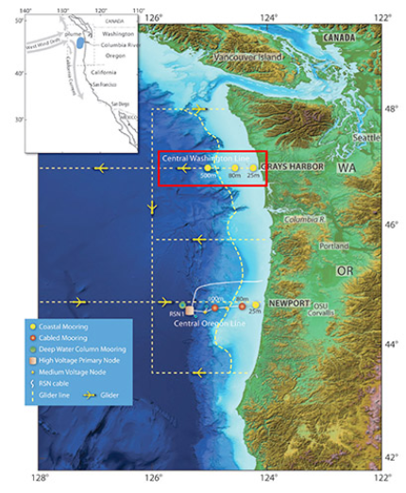
Activity Page: https://datalab.marine.rutgers.edu/explorations/productivity/activity1.php

Seasonal Patterns in Primary Production

- Briefly describe the seasonal patterns you see in primary production throughout the year at the Coastal Endurance Array off the coast of Washington.

- Do these patterns match those we expect to see in temperate regions?

- Briefly describe some of the drivers of the seasonal patterns you see in primary production.

Colored Dissolved Organic Matter
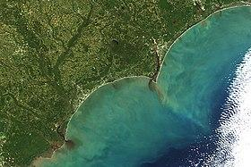
Source: https://earthobservatory.nasa.gov/images/88906/hurricane-matthew-floods-the-carolinas

First, take a couple of minutes to read through the Wikipedia page on CDOM.

- Do you expect CDOM to show a positive or negative relationship with chla?

- Test your hypothesis by zooming into two time periods, one where you expect there to be high sunlight availability and one where you expect there to be low sunlight availability. Briefly explain the patterns you see and any relationships between CDOM and chla.
High
Date Range:
What do you see?

Low
Date Range:
What do you see?

Other Factors Influencing Phytoplankton
- What are two variables that were not measured by this study but that you think would help you to understand phytoplankton dynamics in this system? Discuss at least one abiotic and one biotic variable.

- Do these variables influence phytoplankton abundance through top-down or bottom-up mechanisms?

