OOI Chlorophyll-a in Upwelling vs. Stratified Temperate Regions

Wind drives upwelling that brings cold, salty, oxygen-poor, and nutrient rich waters onto the shelf each spring and summer off the (North Pacific) Oregon coastline (Adams et al 2013). Upwelling delivers nutrients to the surface waters which drives increased photosynthetic activity compared to areas where there is no upwelling (Figure 1). Increased photosynthetic activity (or primary productivity) would produce an oxygen rich environment in areas where upwelling occurs.

Most of the west coast of the United States experiences wind that push surface water away from the coastline. On the east coast of the United States the surface water is density stratified (heterogenous) and upwelling is less common. One would expect the photosynthetic activity on the east coast to be lower than seen on the west coast. One way to measure photosynthetic activity is by measuring chlorophyll-a concentration, the green photosynthetic pigment found in plants, algae, and cyanobacteria. In several areas on the east and west coasts of the United States oceanographic equipment has been collecting several ocean parameters such as temperature, salinity, dissolved oxygen concentration. You will be evaluating this recently collected data to support this assertion.

Figure 1. Upwelling

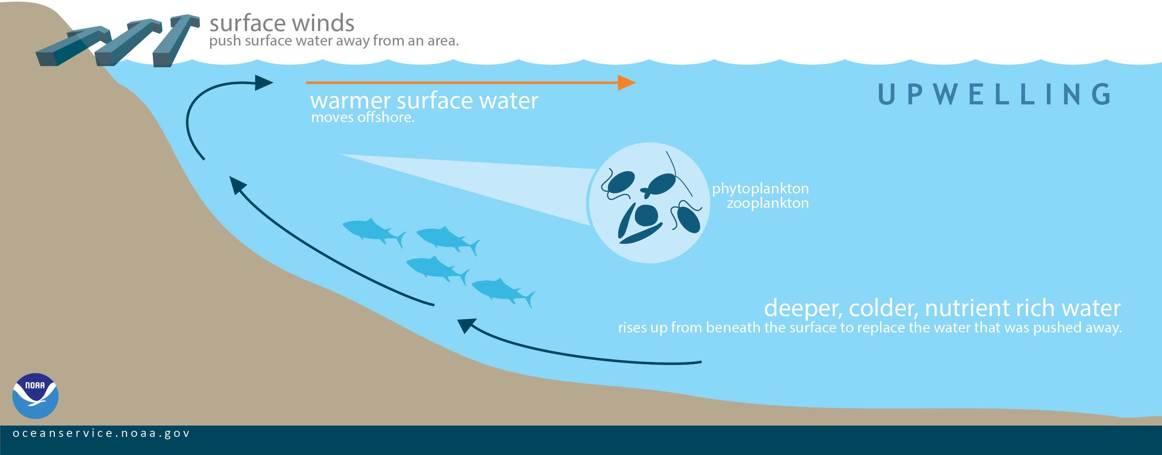

In contrast, most of the east coast of the United States experiences an intense pycnocline from spring to fall (Bumpus 1973). Warm water and higher salinity appears to be the driving factor in developing the pycnocline (Figure 2 below). The density difference between the surface zone (mixed layer) and the pycnocline does not allow deeper colder nutrient rich water to rise to the surface as it does on the west coast of the United States.

Figure 2. Stratification based on pycnocline, thermocline, halocline

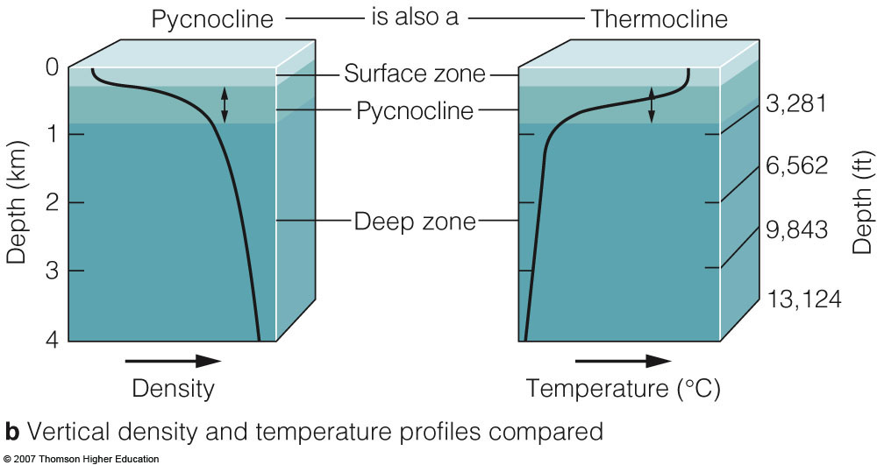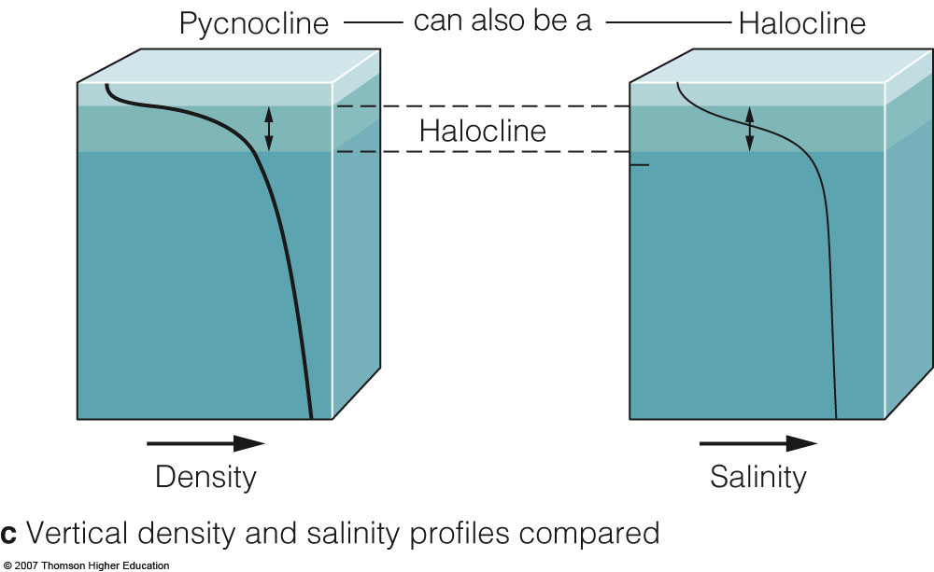

Please examine the data obtained from moored equipment placed on the continental shelf of the Oregon coastline (upwelling occurs) and the East Coast (stratified) to see how water parameters compare in upwelling vs. stratified ocean regions. Please use the following link:

https://datalab.marine.rutgers.edu/explorations/2019/chlorophyll.php

Part I. Exploration: Just look at Oregon in the North Pacific (Endurance)

Please click on “Exploration” box (on left) to observe the graph for Coastal Endurance Array (this is the North Pacific) and answer them below.

Orientation Questions
- How is temperature, salinity, and dissolved oxygen different over the year?

Dissolved oxygen:

Sea surface temperature:

Salinity:

- How should these water characteristics change when upwelling occurs?

Dissolved oxygen:

Sea surface temperature:

Salinity:

Interpretation Questions
- What is the data range and units for chlorophyll a on the y-axis?

- What changes or patterns did you observe at the surface in other variables (temperature, salinity, and dissolved oxygen) as chlorophyll changes over this time period off of Oregon?

Dissolved Oxygen and Chlorophyll-a
Put your cursor on (2016/07/02), what do you notice with chlorophyll-a concentration and dissolved oxygen?

How does this compare to (2016/08/09)? Can you explain why?

Sea Surface Temperature and Chlorophyll-a
Put your cursor on July 2, 2016 (2016/07/02), what do you notice with chlorophyll-a concentration and temperature?

Do you notice the same on (2016/08/09). How is the graph different on this day than in July? Can you explain why the temperature changed?

Salinity and Chlorophyll-a
Put your cursor on July 2, 2016 (2016/07/02), what do you notice with chlorophyll-a concentration and dissolved oxygen?

Do you notice the same on August 9, 2016 (2016/08/09). How is the graph different on this day than in July? Can you explain why the temperature changed?

- What questions do you still have about what drives changes in chlorophyll (primary production) at the ocean surface over time?

Zoom in on each year using the widget (Figure 5) that is below the main graph . How does zooming in confirm or change what you stated in your answers above? Answer the questions below.

Figure 5. Widget

- How many peaks do you see and what time frame (which months/ days/ years on the x-axis, April 2-5, 2016) did you see these changes or patterns taking place?

- In which time frame did you observe the greatest primary productivity? What were the highest Chl-a values (remember to include units)?

- What do you think the driving factor is that causes a difference between these two time frames?

- Watch the animation provided by earth observatory: https://earthobservatory.nasa.gov/global-maps/MYD28M/MY1DMM_CHLORA

Watch how chlorophyll-a changes with sea surface temperature. Does this animation demonstrate what you observed in the Endurance data? Explain.

Part II. Application: Compare North Pacific and North Atlantic
Go back to the home page and then click on “Application”. This will open up to a graph that includes data from both Coastal Endurance (Oregon – North Pacific) and Coastal Pioneer (North Atlantic). Observe the graph and scroll down to the bottom to answer the questions below.

Orientation Questions
- For 2017 what is the temperature, salinity, dissolved oxygen, and Chlorophyll-a values for “Coastal Pioneer” site and when do they peak? First toggle on the Pioneer graph and complete the table below Use the widget to zoom in on the year 2017. Then toggle on Endurance for the same year and do the same.

Coastal Pioneer  Atlantic | Dissolved O2 (µmol/kg) | Temperature  (°C) | Salinity  (ppt) | Chlorophyll-a  (µg/L)
Peak date/value
Coastal Endurance
Pacific
Peak date/value

Interpretation Questions
- Compare the parameters two sites. What season do you observe a peak of Chlorophyll-a in each area?

- Describe the trends in the data? How does Chlorophyll trend with temperature? How does it trend with Salinity? How does it trend with Dissolved oxygen? (example: at lower temperatures the chlorophyll-a concentration is higher)

Atlantic (Pioneer)
Chlorophyll-a and Temp:

Chlorophyll-a and Salinity:

Chlorophyll-a and DO:

Pacific (Endurance)

Chlorophyll-a and Temp:–

Chlorophyll-a and Salinity:

Chlorophyll-a and DO:

- What parameters trend similarly in these two sites?

- Which parameters trend differently? What does this suggest? (Hint: think about how upwelling and stratification would change these parameters)

- What questions do you still have about what drives changes in chlorophyll (primary production) at the ocean surface over time?

Part III. Application (with Prediction)
Go back to the home page and then click on “Application (with Prediction)”. This will open up to multiple graphs that compare Coastal Endurance (Oregon – North Pacific) and Coastal Pioneer (North Atlantic) for each of the parameters. Observe the graphs and scroll down to the bottom to answer the questions below.

- What is your prediction of what will happen with temperature? Was your prediction correct?

