Processes that Change Salinity

Learning Goals:
- Understand processes that cause variation in sea surface salinity
- Build confidence in reading graphs
- Understand that real data can be messy and complicated
- Create hypotheses on causality
This exercise aligns with Course Objectives 1 and 5.

Below is a simplified diagram of the hydrologic cycle (water cycle). There are processes that transfer water and processes that transfer water and solutes.

- Label the processes that transfer water molecules between reservoirs on the diagram.
Use: Precipitation, Evaporation, infiltration, run-off, groundwater flow.

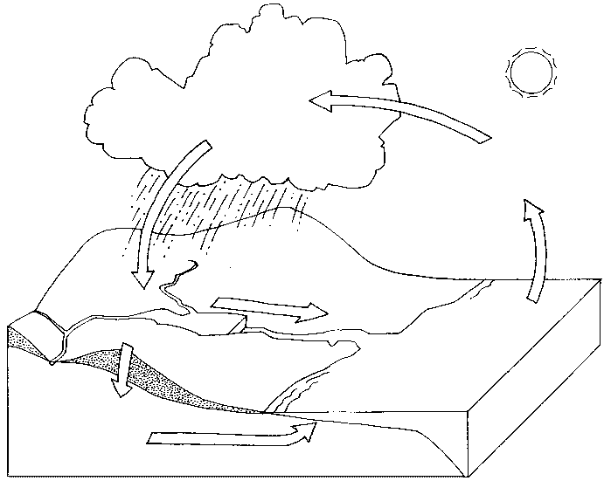

- What do you think controls how active these transport processes are on Earth?—think about deserts vs rainforests.

- Which transport processes in the hydrologic cycle do you think will transport just water?

- Which transport processes in the hydrologic cycle do you think will transport both solutes and water?

- Hypothesize which processes will have the greatest impact on forming higher than average salinity conditions (hypersaline)

- Hypothesize which processes will have the greatest impact on forming lower than average salinity conditions.

Go to this website for the Data Exploration: https://datalab.marine.rutgers.edu/explorations/2019/salinity.php?level=invention

Orientation Questions

Click on the None button so only Salinity is being shown.
- Where were these data collected--Location?

- Across what time periods are you able to observe this variable (month/day/year)?

- What is the highest salinity? What is the date of the highest Salinity?

- What is the lowest salinity? What is the date of the lowest Salinity?

- What season(s) tends to have the highest salinity?

- What season(s) tends to have the lowest salinity?

Interpretation Questions
Click on each parameter to add that parameter.
- What changes or patterns did you observe between Air Temperature and Ocean Salinity?

- What changes or patterns did you observe between Sea Surface Temperature and Ocean Salinity?

- What changes or patterns did you observe between Rain Rate and Ocean Salinity?

- Bring it together!
  - Increasing air temperatures will cause a(n)____________________ of surface
salinities.
Increasing or Decreasing or Unclear
  - Increase sea surface temperatures will cause a(n)_____________ of surface Salinities.

Increasing or Decreasing or Unclear

  - High rates of rainfall will cause a(n)_______________________ of surface salinities
Increasing or Decreasing or Unclear

- Which variable appears to have a stronger control on sea surface salinity in the North Pacific Ocean?

- For the variables you answered ‘unclear’, explain why the relationship was unclear.

- Construct one or more hypotheses as to the reasons behind the relationships between variables, if any. (think about the hydrologic cycle)

