Plate Tectonics and Seamounts
Part 1—Plate Tectonics Refresher
Using the maps provided of Earthquake and Volcanoes, answer the questions and draw on your Plate Tectonic map (PT Map) (refer to last two pages of this handout.)
- On your PT Map, highlight the mid-ocean ridges (spreading centers) with a red pencil.

- On your PT Map, highlight the subduction zones (trenches) with a green pencil.

- Are earthquakes common or rare at or near mid-oceanic ridges? ______________

- Are earthquakes common or rare near subduction zones? _________________

- Are active volcanoes common or rare near subduction zones? ______________

- What do we call a chain of volcanic islands? ____________________________

- What kind of rock is continental crust mostly made of? ___________________

- What kind of rock is ocean crust mostly made of? _______________________

9. Why are the Himalayas Mountains (Mt. Everest) so tall—At the location of Mt. Everest, the plates are moving Away From / Towards one another. Neither plate subducts under the other plate and down into the mantle because both plates are made of_____________________ which has a density that is much ___________________ than the density of Basalt / Granite / the Mantle, so neither plate can sink down into it. Since the plates cannot go Up / Down when they smash together, the only direction the plates can go is Up / Down, which creates _____________________________________.
10. At the location of the Mariana Trench, are the plates moving apart or towards one another? ___________________
11. Why is the Pacific Plate subducting at the trench?

12. At the trench along the coast of Northern California, Oregon, and Washington, are the plates moving apart or towards one another? ____________________________
13. Why is the Pacific Plate subducting at the trench?

14. Why are there so many volcanoes (e.g. Mount St. Helens) along the U.S. Pacific Northwest near the coast and the trench?

15. What type of Plate boundary is the San Andreas? ______________________
16. Why are there no volcanoes along the San Andreas?

17. What type of plate boundary is the Juan de Fuca Ridge? ____________________
18. Are the plates pulling apart or coming together at the Juan de Fuca Ridge? _____________________

Part 2 - Data Exploration
For this part of the lab, you will be using a laptop to look at the seamount along the Juan de Fuca Ridge. Follow the directions closely.
- Go to this website: https://datalab.marine.rutgers.edu/explorations/geology/activity2.php

- Click on “Exploration” and take a moment to scroll down to the bottom while reading the information, and click on the images showing the location of the datasets and the instruments used.

- Now, look at the 2 graphs and answer the following questions. Your cursor can be moved over the data on the graphs to get specific numbers and dates.

- Across what time period are you able to observe depth and angle (tilt from side to side) data of the seafloor in these graphs?

- In what direction (North, South, East, or West) is the angle of the seafloor when there is a negative X-tilt? A negative Y-tilt?

- What changes or patterns did you observe in seafloor depth over this time period at the Axial Seamount?

- When did you see these changes or patterns?

- What changes or patterns did you observe in seafloor angle over this time period at the Axial Seamount?

- When did you see these changes or patterns?

Now, click back to the main page and choose Application #2—Event Impacts.

- What happens to the water temperature during this time period?

- Looking at all three datasets, hypothesize what occurred along the Axial Seamount to cause the changes in depth, tilt, and water temperature.

- What changes or patterns did you observe with the depth, tilt angle and temperature did you use for evidence of your hypothesis?

- What questions do you still have about why the depth and angle of the seafloor as well as the surrounding water temperature changes during an eruption event?
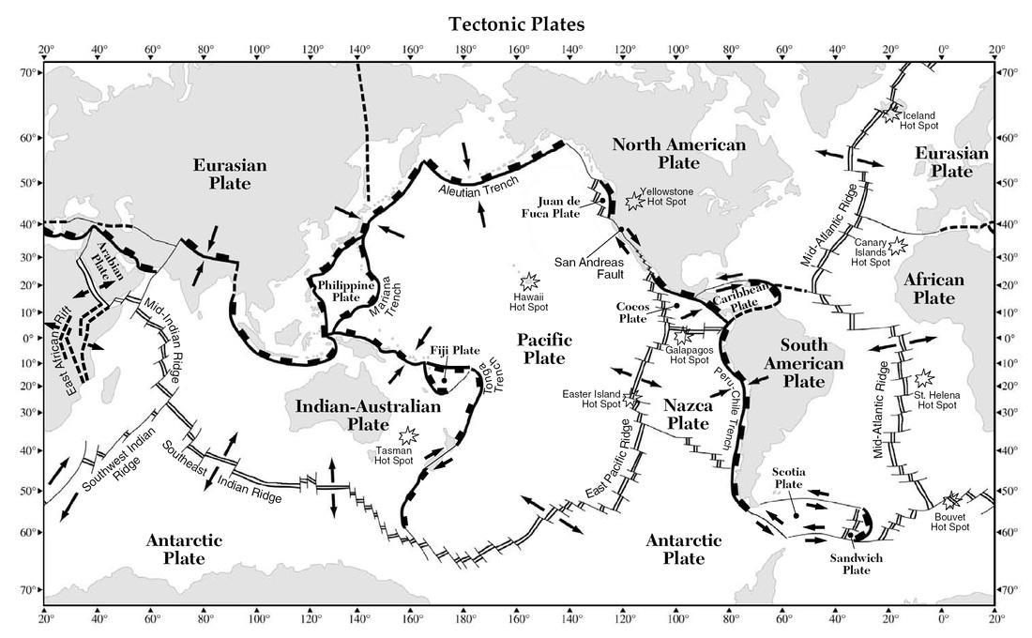
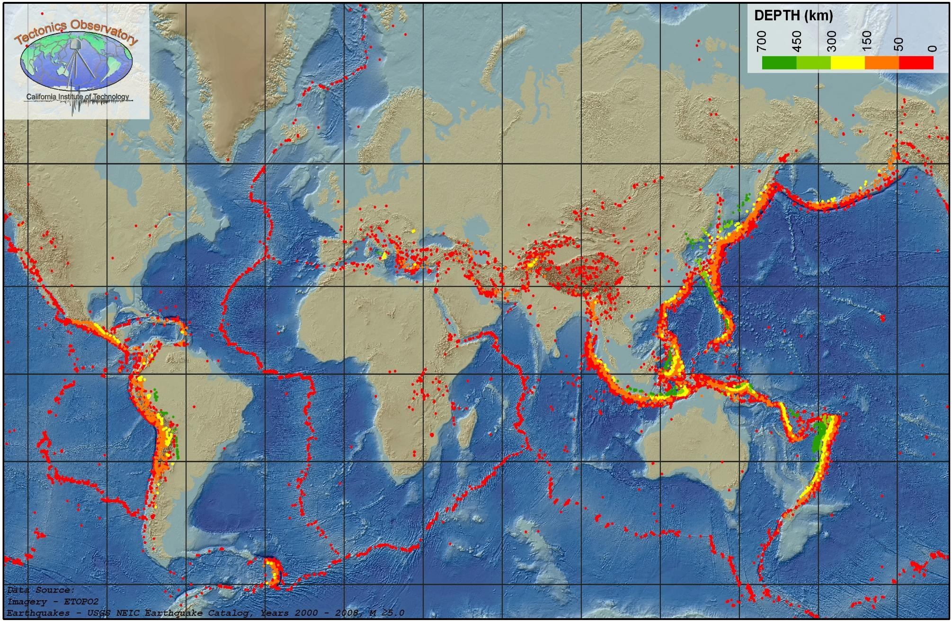
Earthquake map
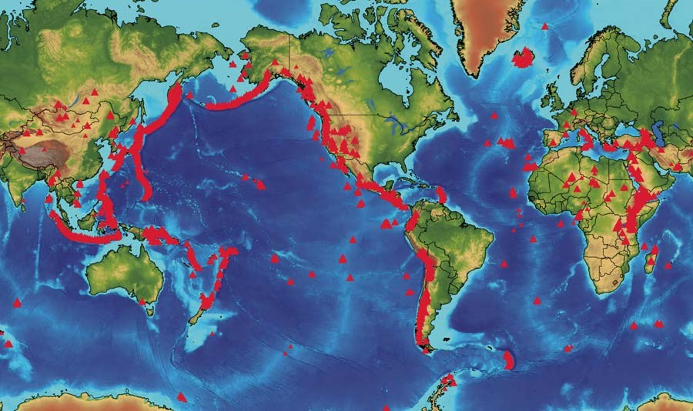
Volcano map

