Plate Tectonics and the Sea Floor

Name: ________________________

Navigate to the OOI Plate Tectonics and the Sea Floor data lab. Spend a few minutes orienting yourself with the map, then answer the questions below.

- What area is shown in the map?

- What does the size of each circle represent?

- What does the color of each circle represent?

Red:

Yellow:

Blue:

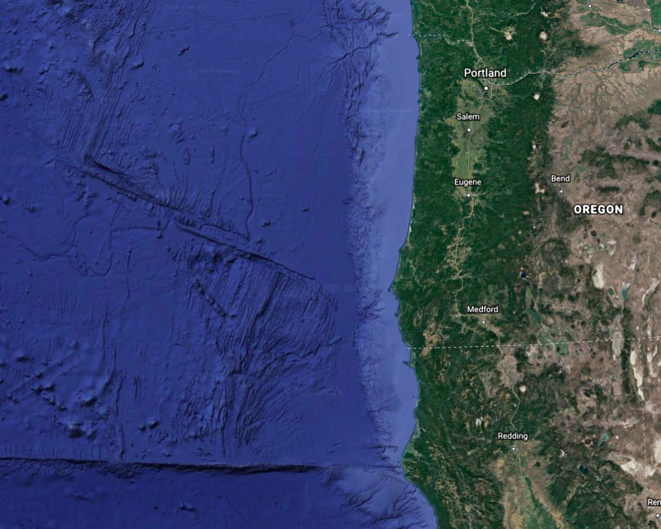
D
C
B
A
Figure 1. Image Source: Google Earth

- For each of the areas outlined above, write down your observations about earthquake frequency, depth, and magnitude.

Area | Frequency (Low, Medium, High) | Earthquake Depth (Shallow, Moderate, Deep) | Earthquake Magnitude (Low, Medium, High)
A
B
C
D

- Judging by your observations, where do you expect “the big one” to originate from? Why?

- Conduct research online to determine what types of earthquakes are typically found at the different plate boundary types.

Boundary Type | Earthquake Depth (Shallow, Moderate, Deep) | Earthquake Magnitude (Low, Medium, High)
Transform
Subduction
Divergent

- According to your research, what type of tectonic boundary is most likely to cause “the big one”?

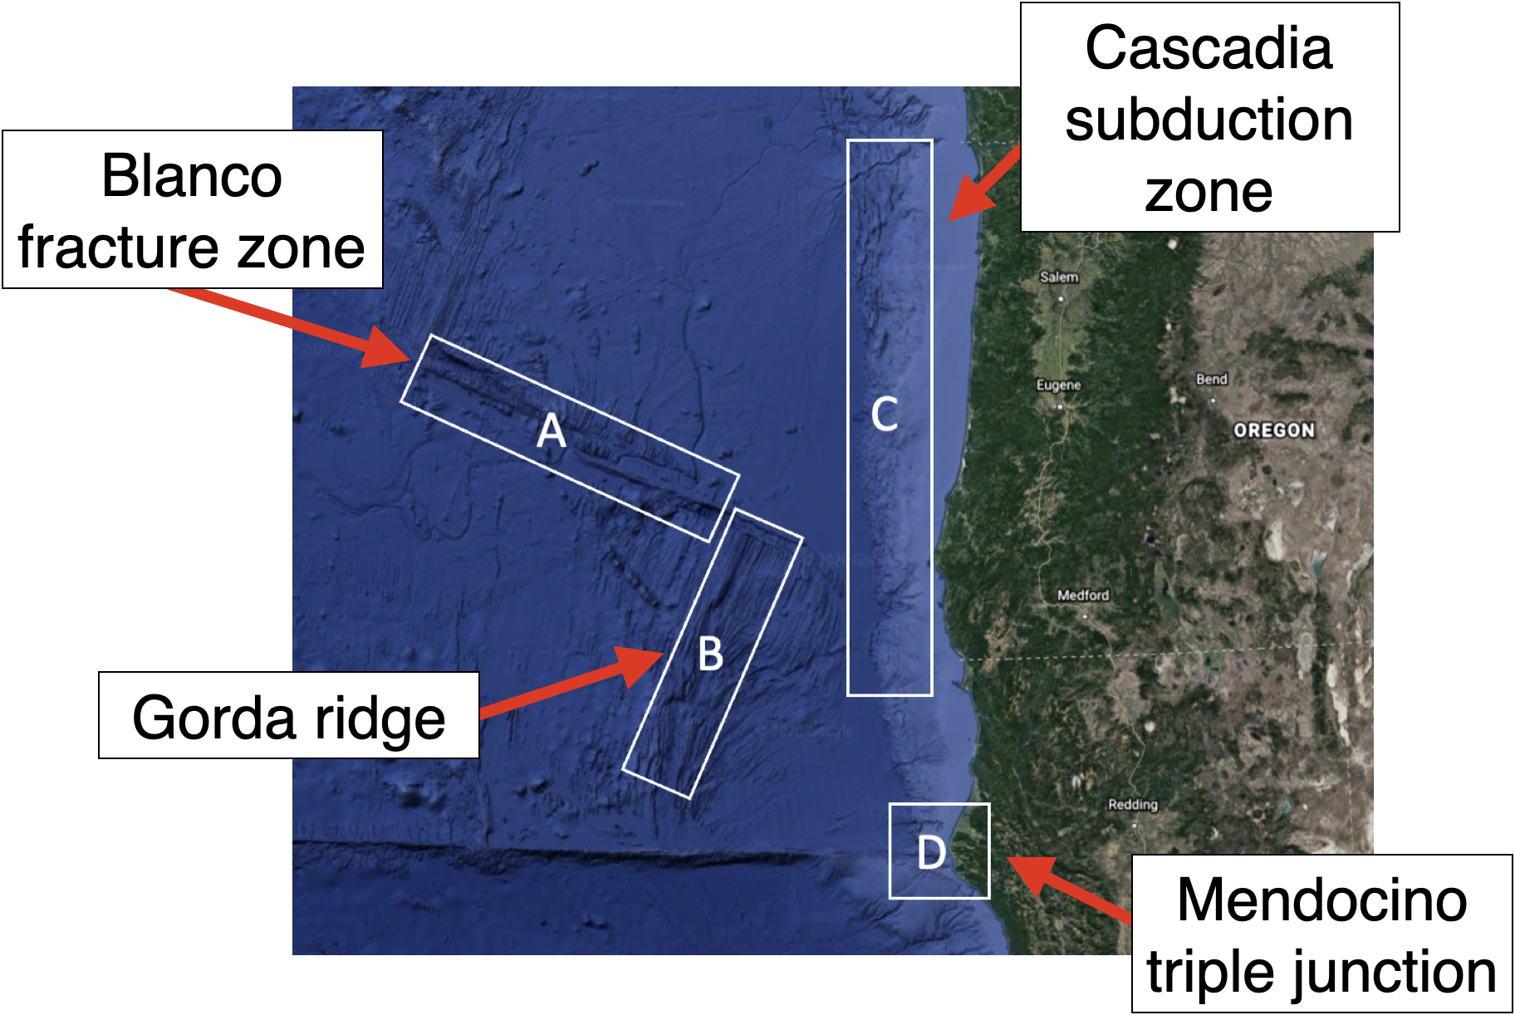

- See the map above for the names of each area. Research each fault online to determine what type of boundary it is – Divergent, transform, subduction, or mix.

Area | Boundary Types (Transform, Subduction, Divergent, Mix)
Blanco Fracture Zone
Gorda Ridge
Medocino Triple Junction
Cascadia Subduction Zone

- Revisit your answer to Question 5. Knowing what you know now, where do you think “the big one” will originate from?
A
B
C
D

- Subduction zones typically produce the highest magnitude and deadliest earthquakes. Why didn’t this show up in the data?

