Oceanography (ES 128)
Spring 2020

Name:

Earthquakes and Eruptions: The Axial Seamount

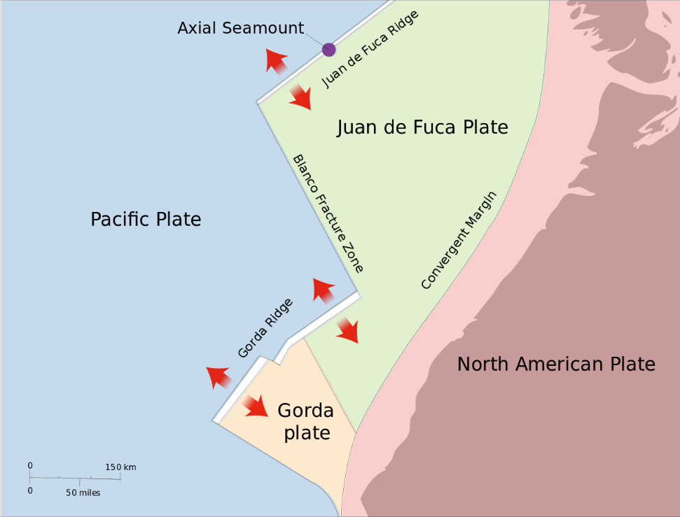
Public domain image of the Axial Seamount provided by Lyn Topinka. https://commons.wikimedia.org/wiki/File:WestcoastSeaplates.svg

- Locate the Axial Seamount on the image above.
  - What type of plate interaction is occurring here?

  - Which plates are involved?

  - What type of crust is involved?

  - Why would you expect active volcanoes here?

- Choose one of the techniques that scientists use to measure volcano deformation and describe it in your own words.

*Wait for instruction before moving onto Question 3.

- Go to the link below to explore the graph of seafloor elevation over time
https://datalab.marine.rutgers.edu/explorations/geology/activity3.php?level=exploration

  - Which dates does this graph start and end? (Hint: put your cursor on the actual line of the graph and move left to right, the dates will be shown in the upper right corner)

  - What variable appears on the y-axis? What are the units?

  - What are the trends in seafloor elevation over time?

  - Click the box next to Show Estimated Threshold. What does this line mean? (Hint: read the Data Tips below the graph)

  - Click and drag your cursor on the graph to make a prediction for what will happen to seafloor elevation leading up to the 2015 eruption. Do the actual observations match your predictions?

*Wait for instruction before moving onto Question 4.

- Go to the link below to explore earthquake magnitude at the Axial Seamount during April, 2015.
https://datalab.marine.rutgers.edu/explorations/geology/activity4.php?level=application

  - What variables are shown on the graph?

  - What is the range of earthquake magnitudes in these data?

  - When do you see the largest earthquakes along this time series across the diking-eruptive event?

  - When do you see the deepest earthquakes along this time series across the diking-eruptive event?

  - How does what you see support what you previously knew about seismic activity at seamounts?

