Learning with Data—Axial Seamount in-class exercise
Learning Goals:
- Build confidence in reading graphs and data
- Understand how scientists use oceanographic data to predict natural disasters
- Build connections between the concepts of plate tectonic activity, volcanoes, and earthquakes
Course Objective Goal alignment with Objectives 1 and 3.
Watch the live video of a hydrothermal vent on the Axial Seamount. https://oceanobservatories.org/streaming-underwater-video/ and Watch “Monitoring Axial” video. https://www.youtube.com/watch?v=_chP9yb73Ck&feature=youtu.be
There were eruptions at the Axial Seamount in January 1998, April 2011, and April 2015.
Earthquakes and Eruptions: The Axial Seamount
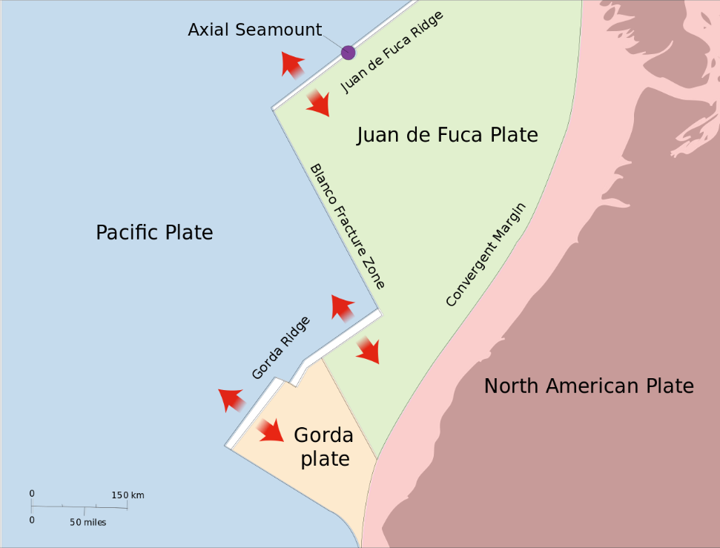
Public domain image of the Axial Seamount provided by Lyn Topinka. (https://commons.wikimedia.org)

- Locate the Axial Seamount on the image above.
  - What type of plate interaction is occurring here?

  - Which plates are involved?

  - What type of crust is involved?

  - Why would you expect active volcanoes here?
- Are there any other plate boundary types in this region?—Which ones?

- Go to the link below to explore the Earthquake and Plate Boundary dataset.
https://datalab.marine.rutgers.edu/explorations/geology/activity1.php?level=exploration

  - What do the different color circles represent on the map?—be specific.

  - What do the different size circles represent on the map?

  - Over how many years is this dataset?

  - Click thru the ‘one month’, ‘6 months’, and ‘one year’ buttons. Which plate boundary type contains the majority of earthquakes?

  - Using the same buttons as above, in general, which boundary type has the largest magnitude earthquakes?

  - Using the same buttons as above, in general, which boundary type has the deepest earthquakes?

  - Scroll along the earthquake data so as to highlight the data from 2011 to 2017. In what 2 years do earthquakes occur on the Axial Seamount (if need help finding it, you can use the image on this worksheet or the images at the bottom of the dataset website or ask me for help.)

- Go to the link below to explore the graph of seafloor elevation over time
https://datalab.marine.rutgers.edu/explorations/geology/activity3.php?level=exploration

  - What are the dates covered in this data? (Hint: put your cursor on the actual line of the graph and move left to right, the dates will be shown in the upper right corner)

  - What variable appears on the y-axis? What are the units?

  - What are the trends in seafloor elevation over time?

  - Click the box next to Show Estimated Threshold. What does this line mean? (Hint: read the Data Tips below the graph)

  - Click and drag your cursor on the graph from 2012 onward to make a prediction for what will happen to seafloor elevation leading up to the 2015 eruption. Do the actual observations match your predictions?

  - Hypothesize why the seafloor would inflate prior to an eruption and then deflate after an eruption?

  - Besides the inflation of the seafloor, what other events indicated that an eruption of the Axial Seamount was eminent?

  - Do you think these same events would help Geologists predict Volcanic eruptions on land, such as at Mount Rainer, Mount St. Helens, and Yellowstone?

Watch this video: https://www.youtube.com/watch?v=AYla6q3is6w

