Anoxic Events

Name: _________________________

Part 1 - Introduction
- Describe what anoxia is and why it is important.

- Brainstorm some causes for anoxia in marine ecosystems.

Part 2 – Data Exploration
Open the OOI Anoxic Events Data Lab on your computer. Spend 5 minutes exploring the information on this page.

- Examine each data set and explore how it changes through time. Describe in 1-2 sentences how each data set changes over the sampling period, using phrases such as “lower” and “higher”.
  - Dissolved oxygen:

  - Temperature:

  - Wind direction:

- Which of these variables (dissolved oxygen, temperature, wind direction) appear to be related? Is the relationship what you expected?

- Draw the direction that a southward wind moves on the map below.

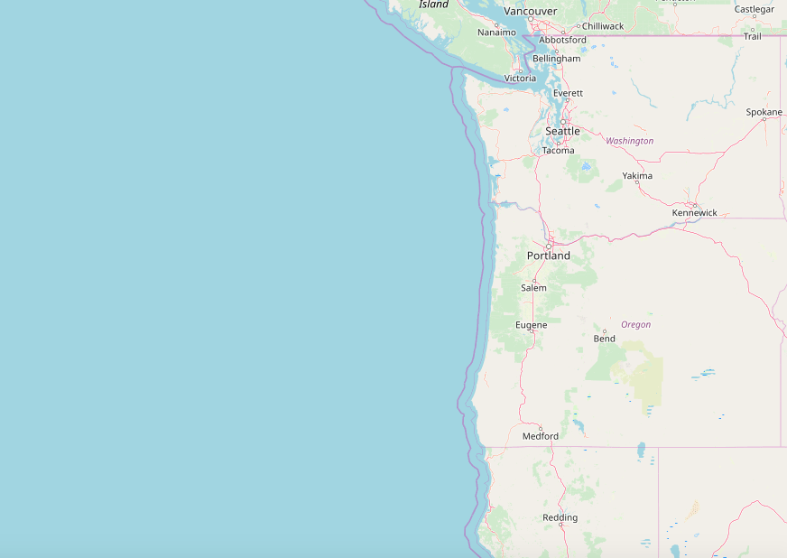
Figure 1. The Washington and Oregon coast. Adapted from: www.openstreetmap.org

- What direction does water move with a southward wind? Draw an arrow on the map from Question 5.

- Why do you think low dissolved oxygen, low temperature, and southward winds are related?

Part 3 – Putting it Together
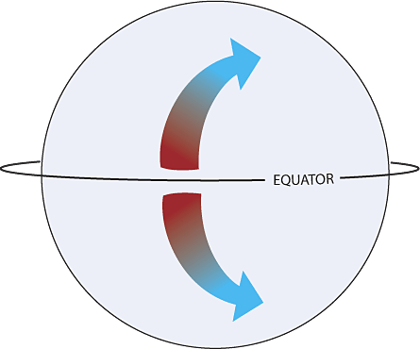
Revisit your surface water current arrow on the previous page. Did you draw water moving in the same direction as wind? Although this seems logical, wind is only part of the story. The earth’s rotation also affects water movement.
Figure 2. Due to the earth's rotation, surface water is deflected to the right of wind in the Northern Hemisphere. From: www.oceanservice.noaa.gov

As the earth rotates, water in the Northern Hemisphere is deflected to the right, while water in the Southern Hemisphere is deflected to the left. This is called the Coriolis effect. This means that water does not exactly follow the direction of the wind, but instead is deflected to the right of the wind.

- Redraw your surface water current arrow under a southward wind to reflect the Coriolis effect.
Figure 3. Southward wind blows towards the south. Adapted from: www.openstreetmap.org

- With this new information, revisit your explanation of how low dissolved oxygen, low temperature, and southward winds are related.

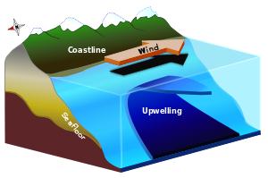
When wind blows southward, water is deflected offshore due to the Coriolis effect. This causes deeper waters to upwell near the coast.
Figure 4. Deeper water upwells near the coast when wind blows southward. From: www.wikipedia.org.

- Would you expect deeper water to be higher or lower than surface water in:
  - Temperature:

  - Dissolved oxygen:

- Using this information, explain why southward winds results in temperature and dissolved oxygen decreases off the Oregon Coast.

Part 4 – Seasonal Patterns

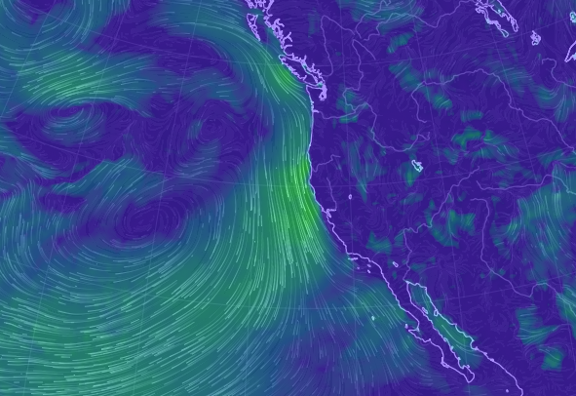
As you saw from the dataset, water is deflected offshore with a southward wind due to the Coriolis Effect. This happens on a daily basis, but there are also seasonal trends in wind direction.

Visit https://earth.nullschool.net. This website gives a visualization of oceanic and atmospheric processes. Click on the “earth” icon in the bottom left corner and explore the options.

Zoom in to the Oregon Coast. Select “air” for the mode and “wind” for the overlay. Explore wind direction in summer and winter of any years.
Figure 5. Visualization of wind direction off the US West Coast. From: https://earth.nullschool.net

- On the map of the Oregon Coast below, draw arrows showing:
  - The direction of wind in the summer
  - The direction of wind in the winter
Figure 6. The Washington and Oregon cost. Adapted from: www.openstreetmap.org

- Would you expect more upwelling off the Oregon coast in summer or winter? Why?

