LAB 2 – BUILDING DATA SKILLS

Name: Section number _____________
Complete the lab and use this form as your answer sheet. Type answers in the Text boxes which will expand as you type in them

Lab 2.1 - Reading a time series graph
- What was the start and end date for data collection?
Start:
End:

- What variable is plotted on the y-axis of this graph and what are the units?
Variable:
Units:

- How does this variable vary throughout the year? Does the variation make sense?

- A trend in a time series is when there is a gradual change (i.e., an increase or decrease) over time, depth or distance. What trends do you see in these data?

- What is the start and end date of the data collection in Figure 2.1.2?
Start
End

- Notice that there is a gap in the data. What does that gap mean?

- Are there any trends in the data? What do you think causes them?

- What are the maximum and minimum values in the data?
Maximum
Minimum

- Considering your answers to these questions can you explain the “messiness” of the data in the first graph (Figure 2.1.1)?

- What are the maximum and minimum temperature values, and what do you think causes them?
Maximum
Minimum

- The graph above (Figure 2.1.3) looks much “neater” than the previous graphs. This is because much of the detail has been lost in the averaging process. Is this a fair trade-off if you want to look at seasonal changes in temperature?

- Is one or more trend(s) evident in the monthly mean temperature data shown in the figure 2.1.3? Describe the trend(s).

- Based on Figure 2.1.4 are there any trends in the water temperature data? What are they?

- What is the maximum and minimum in the water temperature and when do they occur (Figure 2.1.4)?
Maximum |  | When?
Minimum |  | When?

- How does the seasonal range in water temperature compare to the seasonal range in air temperature? Why do you think that they aren’t the same?

- Is water temperature correlated with air temperature? In other words, as one temperature series increases or decreases does the other one also change?

- What are the maximum and minimum values for sea surface salinity in Figure 2.1.5?
Maximum
Minimum

- Are there any trends in the salinity data? What are they?

- Notice that you can click and drag the two scroll bars at the bottom of the graph to zoom in and out to different portions of this graph. Zoom in so that only April and May are visible. Does there appear to be a correlation between sea surface temperature and salinity? If so, what type of relationship did you find between temperature and salinity?

- Now zoom out to view the rest of the year. Does the same relationship between sea surface salinity and temperature hold for the whole year?

- Look back to the beginning of this exercise to see the ranges in temperature in the ocean versus on land. Now examine the Coastal Pioneer Array data in Figure 2.1.4. What is the measured range for air and ocean temperatures in the Coastal Pioneer Array data? How does this compare to the ranges for air and ocean temperature extremes?

Lab 2.2 - Bathymetric charts
- Follow along with the video above to complete the bathymetric profile exercise. On your own graph paper or printout supplied by your instructor, draw the slope from point A to B and from point B to C.

- Which side of the East Flower Garden Bank, northern (A-B) or southern (B-C) is the steepest?

- Estimate the depth of the seafloor at 27° 56’ N, 93° 37’ W. Remember that the depth changes continuously between contours.

- Hard corals (the ones that build reefs) are found on top of the bank, down to a depth of approximately 50 meters. If an ROV collected video footage of the location in Question 2 (27° 56’ N, 93° 37’ W), would you expect to see living coral reef habitat? Why or why not?

- Describe the relationship between color shading and depth of the seafloor in Figure 2.2.3.

- What can you look for in the colors on the map to locate a steep area of the seafloor?

- Locate the two shallowest features at the top of the bank (depth less than 20 meters). Describe the shape and texture of these two locations in as much detail as possible. Are they round or irregular? Smooth or rough? Flat or peaked?

- Now examine the areas that are deeper than 100 meters. Which side of the bank, east or west, has small bumpy features? Were those features visible in the contour maps?

- Between points B and C is the continental slope, the transition to the deep open ocean basin. The depth of the seafloor at point C is approximately 3,300 meters, compared to 300 meters at point B. The distance between points B and C is 36,000 meters. Calculate the slope. (show your work).

- Federal highways in the United States generally have a maximum slope of 6% and display warning signs for trucks if the slope of the road exceeds that amount. If the continental slope west of Florida (between B and C) was a mountain roadway, would it need a warning sign?

- We have examined three versions of bathymetric charts (labeled contour lines, filled contours with a color scale, and shaded relief). What are the benefits and drawbacks of using a shaded relief chart compared to a contour map?

Lab 2.3- How can several variables be presented on a map?
- Which version, bubble size or bubble color, do you think is a better way to show differences in oil spill size? Why?

- Examine the color of the shipwreck markers in Figure 2.3.3. In which decade did the largest number of shipwrecks occur?

- Are the most recent shipwrecks in this dataset closer to land or further out at sea compared to the oldest shipwrecks?

- Find the shipwreck that occurred in the 1970’s. What was the approximate length of this ship?

- Do you see a pattern in the ship length compared to the proximity of the shipwreck to the coastline? If so, what is the pattern that you see? If not, why do you think these two variables are unrelated?

- Treacherous shallow waters are marked in a variety of ways to assist boaters in making a safe passage. These markers, which include lighthouses and bell buoys, are located on the water or on land, and are also marked on navigation charts. Navigational markers do not exist in the deep ocean, although maritime disasters can still happen there. What might cause ships to sink in deep water?

- Can you think of a way to indicate the cause of a disaster on a bubble chart? If so, how would you show this information? If not, why is it difficult to display that type of information in a bubble chart format?

Lab 2.4 - Station profiles, how to read a standard oceanography graph
- Why it is useful to make a station profile graph with this orientation (depth increasing downward)?

- Identify the maximum and minimum temperature values in this station profile graph from the Pioneer array (Figure 2.4.5).
Maximum
Minimum

- How does the temperature of the water change as you go deeper in the water?

- The depth where the temperature changes the most rapidly is called the thermocline. What is the depth of the bottom of the thermocline in this profile?

- North Atlantic fin whales migrate through the area of the Pioneer array. These whales breathe air at the surface and dive to feed on krill, squid and other prey. If a fin whale dove from the surface to 100 meters deep at the time and location that this profile was collected, how much change in temperature would it experience? (Assume that surface temperatures are equivalent to the temperature at a depth of 35 meters)

- Identify the maximum and minimum temperature values in this station profile graph from the Irminger Sea (Figure 2.4.6). How does the temperature of the water change as you go deeper in the water?

- Now compare the Pioneer and Irminger temperature profiles. How similar or different are these two station profiles?

- Click the buttons in Figure 2.4.6 to match the depth and temperature scales. Did your answer to the previous question change when you did this?

- Why do you think these two temperature profiles are so different? [Hint: Click below to view the location of the two arrays]

- When comparing two or more data sets why is it important to compare the scales? Use an example from this station profile activity to support your answer.

Lab 2.5 - Vertical sections
- In the vertical section, which colors represent warm water? Which represents cool water?

- Describe the change in temperature from surface to bottom, based on this color coding, near the left side of the vertical section. This is over the outer continental shelf.

- Describe the change in temperature from surface to bottom on the right side of the vertical section. This is in deeper water over the continental slope. The water column is at this location much deeper than 400 meters, but just the upper 400 meters of the water column are shown.

- Would you say that there is a consistent trend in the way the temperature changes with depth?

- Now draw a station profile for Station B. (Draw or insert image)
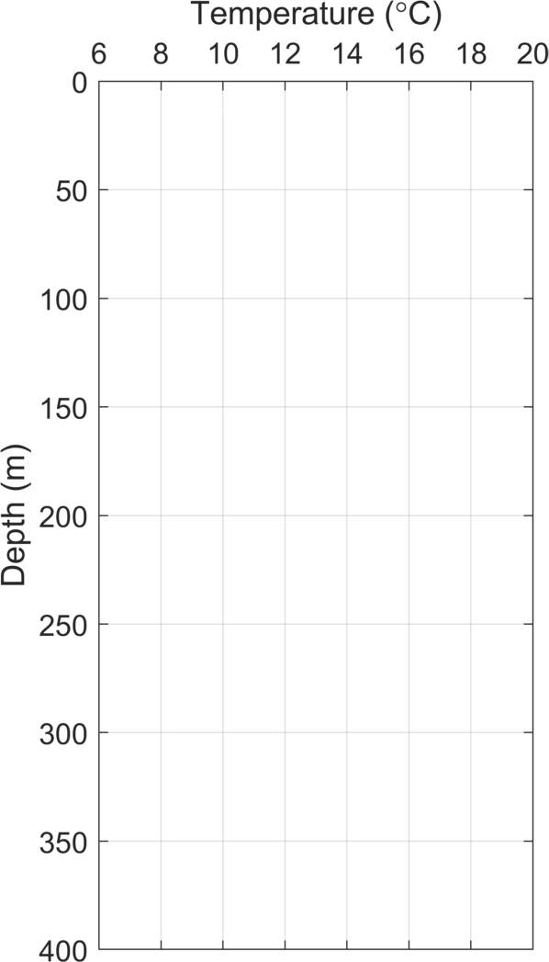

- The portion of the water column near the surface with uniform temperature is called the surface mixed layer. The surface mixed layer at Station A extends to 50 m deep. How deep is the surface mixed layer at Station B?

- Below the surface mixed layer, temperature changes rapidly with depth. This is called the thermocline. At what depth does the temperature stop changing rapidly as depth changes? In other words, if you could dive into this part of the ocean, at what depth would you stop experiencing a lot of temperature change?

- In the vertical section, how do the colors show us depths with rapidly changing temperature vs. uniform temperature? How do the contour lines show us this same information?

