Name:

CO₂ and pH in a System with Seasonal Upwelling

Today, we are going to explore seasonal trends in ocean CO₂ concentrations off the coast of Oregon and link these trends to ocean pH at this location. Next, we will study how physical ocean processes (upwelling) drive biological ocean processes (photosynthesis) in this system.
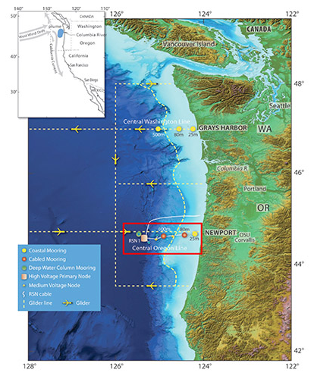

Trends in Ocean CO₂ and Ocean-Atmosphere Interactions
- First, take a closer look at trends in atmospheric CO₂ at the Mauna Loa Observatory, located in Hawaii.

Approximately what was the atmospheric CO₂ in 2015-2016 in parts per million?

- Now, let's explore ocean CO₂ trends off the coast of Oregon during the same time period. The figures on the link below show three things: 1) the relationship between CO₂ concentrations and ocean pH, 2) trends in ocean pH over time, and 3) trends in ocean CO₂ over time.

- What is the range of ocean CO₂ values throughout this time period?

- What is the range of ocean pH values throughout this time period?

- What is the relationship between ocean CO₂ and ocean pH?

- What are the seasonal patterns in ocean CO₂ at this location? Generally, during which times of the year is the ocean a sink for CO₂?

- What are the seasonal patterns in ocean pH at this location? When is the ocean most acidic?

Seasonal Upwelling off the Coast of Oregon
Next, we will look at data for wind patterns in the winter (December 2015) and summer (July 2015) during this time period. We will do this using data from the Northwest Association of Networked Ocean Observing Systems. When you click on the link, zoom into the same location as the data from OOI (Newport, Oregon). This location is located to the south and west of Salem and is along the coast (coordinates of 44.6252, -124.0803). There are two site indicators (yellow dots) covering the town name.
- First, click on "Winds (Climate)" under the layers tab. You can use the scroll bar at the bottom to navigate to a different month.

How do the wind patterns along the coast of California vary in December versus in July of 2015?

- Next, scroll down under layers and click on "Chlorophyll (Climate)". The legend at the bottom left-hand corner will tell you what the chlorophyll concentrations are at each location. Remember that higher chlorophyll concentrations mean that there are higher levels of photosynthesis occurring at that time/location.

  - When are there higher rates of photosynthesis along the coast, in December or July?

  - Approximately how much higher are chlorophyll concentrations during the month you chose for 9a?

  - Given what you know about this system, briefly describe what is causing this seasonal variation.

Links Between Upwelling and Ocean Chemistry
For the last step, let's go back to the OOI data. Compare the months of December and July. You can select a specific time period by drawing a box over that month on the pH profile using your cursor.
Remember that upwelling can have two impacts on ocean surface CO₂ levels:
- An increase in CO₂ levels when deep ocean water is brought to the surface. Remember that higher pressure = higher gas concentrations. Deep ocean CO₂ levels are also higher due to a lack of photosynthesis and the breaking down of sinking organic matter through respiration.
- A decrease in CO₂ levels due to an influx of deep-water nutrients and, as a result, higher rates of photosynthesis.

- How does the range of CO₂ values compare in December and in July?

- Why do you think you see this trend, based on what you know about upwelling's impact on surface CO₂?

