Fun With Analyzing Ocean Data
By Katie McDonnell, August 2020

The Jersey Shore, specifically the Atlantic City area is a common destination for tourists during the summer months. While visiting the beach, many people enjoy swimming in the ocean. Although you may know that swimmers and beachgoers may check the sea surface temperature for their recreational activities, have you thought about how scientists collect and analyze this data?

In this activity, you will learn about how scientists interpret this data and practice analyzing sea surface temperature data yourself.

Before scientists analyze their data, they have to collect it first. A large portion of the data scientists have about the ocean comes from buoys, or anchored floats with data collection instruments inside. Buoys collect many different types of ocean data each day, including sea surface temperature, wind speed, wave height, and many more.

The National Data Buoy Center, part of the National Oceanic and Atmospheric Administration (NOAA), collects data from over 1,400 buoys and shore stations throughout the world, including about 20 along the New Jersey Coast. For example, we will use Station ACYN4, located off the coast of Atlantic City, New Jersey, indicated by the orange circle in this map.
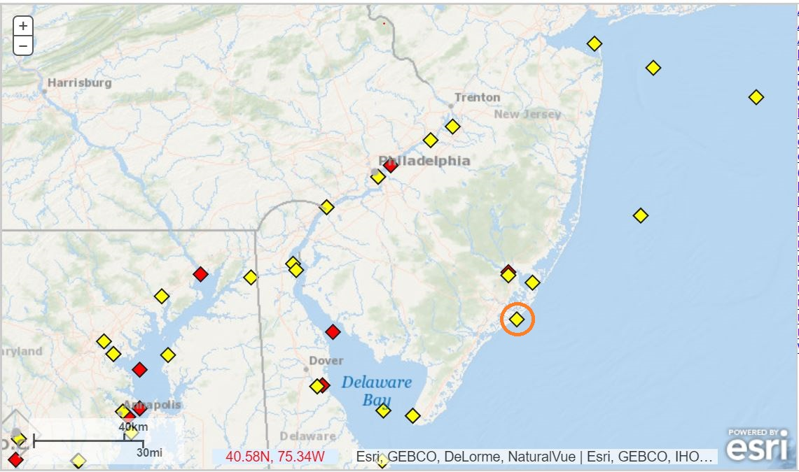
Source: NOAA

One Week
First, let's look at sea surface temperature data from the first week of June 2020 in Atlantic City.

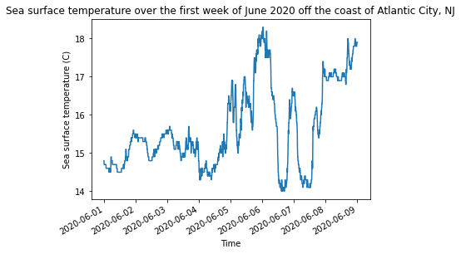
1a. What was the sea surface temperature on June 4th?

1b. What was the range of temperatures experienced over the first week of June off the coast of Atlantic City?

1c. What was the average temperature this week? (Hint: Note the temperature each day, add the temperatures together, and divide by the number of days in a week)

One Month
Next, let's look at sea surface temperature data collected over the entire month of June 2020 off the coast of Atlantic City.

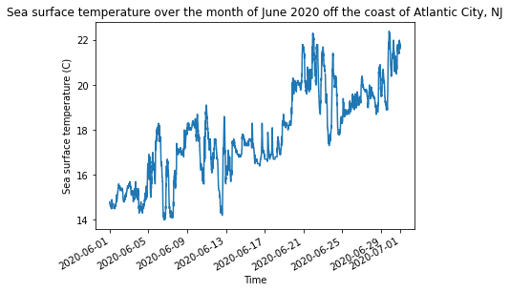
2a. What is the overall trend of the sea surface temperature in June? Describe the trendline you would draw on the graph.

2b. What was the range of temperatures experienced over the month of June? How does this compare to the range of temperatures experienced over the first week of June only?

One Year
Now that we have looked at sea surface temperature data from the month of June 2020, we can now look at sea surface temperature data from the past year (June 2019-June 2020).

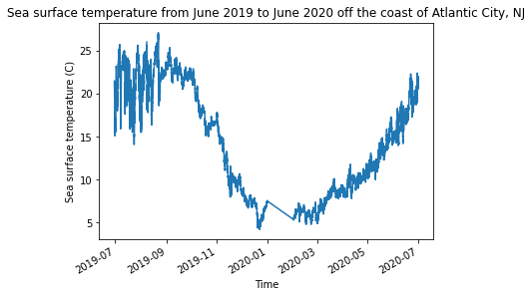
3a. What is the overall trend or pattern of the sea surface temperature over the past year?

3b. What month is the sea surface temperature the coldest? What month is the sea surface temperature the warmest?

3c. Does the data presented in the graph confirm or challenge your personal observations and experiences? Explain.

Over a Decade
Next, let's look at the sea surface temperature in Atlantic City since 2004.

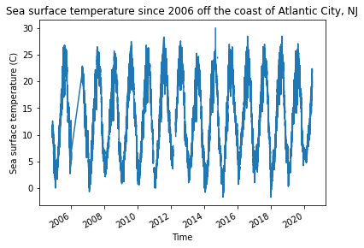
4a. What trends or patterns do you notice in the sea surface temperature? Explain.

4b. Which year had the highest sea surface temperature? Which year had the lowest sea surface temperature?

4c. What do you notice about the minimum sea surface temperature in 2020?

Comparing 2 Locations
Next, we can compare our observations about the sea surface temperature in Atlantic City to the sea surface temperature in another tourist destination: Key West, Florida, using data from Station KYWF1.

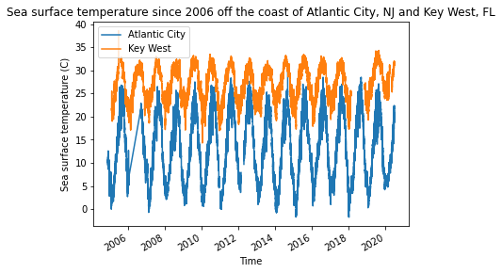
5a. What differences do you notice between the sea surface temperature in Atlantic City and the sea surface temperature in Key West?

5b. Which beach would you rather go swimming at? Explain.

