LAB 2 – THE DISPLAY OF OCEANOGRAPHIC DATA

Name: Section number _____________
Complete the lab and use this form as your answer sheet. Type answers in the Text boxes which will expand as you type in them.

LAB 2.1 – READING A TIME SERIES GRAPH
Figure 2.1.1
- What was the start and end date for data collection?
Start
End
- What variable is plotted on the y-axis of this graph and what are the units?

- How does this variable vary throughout the year? Does the variation make sense?

- A trend in the data is when there is a gradual change, i.e. an increase or decrease, over time, depth or distance. Are there any trends in these data?

Figure 2.1.2
- What is the start and end date of the data collection in Figure 2.1.2?
Start
End

- Notice that there is a gap in the data. What does that gap mean?

- Are there any trends in the data? What do you think causes them?

- What are the maximum and minimum values in the data?
Maximum
Minimum

- Considering your answers to these questions can you explain the “messiness” of the data in the first graph?

Figure 2.1.3
- What are the maximum and minimum temperature values, and what do you think causes them?
Maximum
Minimum

- The graph above (Figure 2.1.3) looks much “neater” than the previous graphs. This is because much of the detail has been lost in the averaging process. Is this a fair trade-off if you want to look at seasonal changes in temperature?

- Is one or more trend(s) evident in the monthly mean temperature data shown in the figure 2.1.3? Describe the trend(s).

- Based on Figure 2.1.4, are there any trends in the sea surface temperature data? What are they?

- What is the maximum and minimum in the sea surface temperature and when do they occur (Figure 2.1.4)?
Maximum
Minimum

- How does the seasonal range in sea surface temperature compare to the seasonal range in air temperature? Why do you think that they aren’t the same?

- Is sea surface temperature correlated with air temperature?

- What are the maximum and minimum values for sea surface salinity (Figure 2.1.5)?
Maximum
Minimum

- Are there any trends in the salinity data? What are they?

- Notice that you can click and drag the two scroll bars at the bottom of the graph to zoom in and out to different portions of this graph. Zoom in so that only April and May are visible. Does there appear to be a correlation between sea surface temperature and salinity? If so, what type of relationship did you find between temperature and salinity?

- Now zoom out to view the rest of the year. Does the same relationship between sea surface salinity and temperature hold for the whole year?

Reflection
- Real data often looks “messy”. It becomes neater if one averages the data, but this removes the information about any variability within the averaged data. If you were to take all of the salinity data collected at a river mouth and create yearly averages (i.e. average all the data for each calendar year) what kind of detail do you think you will lose? In other words, what natural processes will be lost in the averaging? What might you gain from doing such an average?

LAB 2.2 – STATION PROFILES, HOW TO READ A STANDARD OCEANOGRAPHY GRAPH
- Can you speculate on why it is useful to make a station profile graph with this orientation?

- Identify the maximum and minimum temperature values in this station profile graph from the Pioneer array, off the mid-Atlantic U.S. coast.
Maximum
Minimum

- How does the temperature of the water change as you go deeper in the water?

- The depth where the temperature changes the most rapidly is called the thermocline. At what depth is the thermocline in this profile?

- North Atlantic fin whales migrate through the area of the Pioneer array. These whales breathe air at the surface and dive to feed on krill, squid and other prey. If a fin whale dove from the surface to 100 meters deep at the time and location that this profile was collected, how much change in temperature would it experience?

- Identify the maximum and minimum temperature values in this station profile graph from the Irminger Sea (Figure 2.2.2). How does the temperature of the water change as you go deeper in the water?

- Now compare the Pioneer and Irminger temperature profiles. How similar or different are these two station profiles?

- Click the buttons in Figure 2.2.2 to match the depth and temperature scales. Did your answer to the previous question change when you did this? (NOTE: It’s OK if your answer changes – do not change above answers, it’s part of learning!

- Why do you think these two temperature profiles are so different? Look back at the location of these two arrays.

Question for reflection
- When comparing two or more data sets why is it important to compare the scales? Use an example from this station profile activity to support your answer.

LAB 2.3 – BATHYMETRIC CHARTS
- The depths on NOAA charts are given in feet. Locate the deepest point on the chart. Each story of a building is typically 10 feet high. How many stories would a building have to be to project above the water if it sat on the seafloor at the deepest point on the chart?

- Scientists typically work in the metric system. Take the deepest point on the chart and convert the depth to meters (1 ft = 0.3048 m).

- Identify the latitude and longitude of deepest point (in degrees, minutes and seconds).
Latitude
Longitude

- The NOAA chart contains information specifically used in navigation, like buoys that are placed and maintained to aid vessels in safe passages. Notice on the chart there is a symbol labeled G “3” Fl G 2.5s. This is a buoy used to navigate into the harbor. This particular one has a green light that flashes every 2.5 seconds. Locate this buoy and record its latitude and longitude.
Latitude
Longitude

- Why is this buoy not located further to the east? Use the color-coded bathymetry map below the NOAA chart to support your answer.

- Can you identify valleys in the sea floor from the color coding? Locate the largest valley, it’s landward end is located in Monterey Bay. Note that a river empties into the ocean near this valley.
  - How might this submarine valley have formed?

  - Follow the submarine valley seaward. How deep is it at the deepest end?

  - By what process might this valley have been carved in such deep water?

LAB 2.4 – VERTICAL SECTIONS
- In the vertical section, which colors represent warm water? Which represents cool water?
Warm
Cool

- Describe the change in temperature from surface to bottom, based on this color coding, near the left side of the vertical section. This is over the outer continental shelf.

- Describe the change in temperature from surface to bottom on the right side of the vertical section. This is in deeper water over the continental slope. The water column is much deeper than 180 meters, but the glider stopped at that depth.

- Would you say that there is a consistent trend in the way the temperature changes with depth?

- Now draw a station profile for location B. The portion of the water column near the surface with uniform temperature is called the surface mixed layer. The surface mixed layer at station A extends to 50 m deep. How deep is the surface mixed layer at Station B?
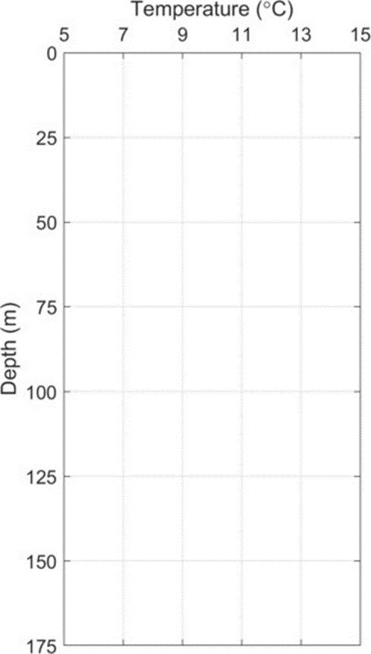

- Below the surface mixed layer, temperature changes rapidly with depth. This is called the thermocline. At what depth does the temperature stop changing rapidly as depth changes? In other words, if you could dive into this part of the ocean, at what depth would you stop experiencing a lot of temperature change?

- In the vertical section, how do the colors show us depths with rapidly changing temperature vs. uniform temperature? How do the contour lines show us this same information?

LAB 2.5 – BUBBLE CHARTS
- Can you think of a way to modify the dots used to plot earthquake locations so they also contain information about the depth of the earthquake?

- What is the depth of the earthquakes that are closest to the trench?

- What is the depth of the earthquakes that are farthest from the trench?

