Sample Salinity, Temperature, Density and Stratification Activity
This activity examines the impact of temperature and salinity on density and stratification through hands on activities and demonstrations, as well as explores the processes that effect salinity in both space and time using real-world OOI data. This activity is designed for an Introduction to Oceanography course and implemented after lecture, demonstration and discussion of impact of temperature and salinity on density and stratification. Concepts of thermocline, halocline and pycnocline should be introduced prior to or as part of beginning lab demonstrations and activities. This activity is typically run in a 3 hour lab period and requires that students have access to laptops and the internet.

Learning Goals
- Explore the effect of temperature on water density
- Explore the effect of salinity on water density
- Learn about stratification and be introduced to the concepts of thermocline, halocline and pycnocline
- Explore the effect of density differences on stratification
- Explore processes that affect salinity, seasonal variations in salinity and how salinity changes with depth over time in different areas of the ocean using real-world OOI data.
- Become more comfortable working with and interpreting data in timeseries and profile formats
Acivity Description
- Have students set up and do fish tank demonstration using food coloring of warm versus cold water and salty versus fresh water and discuss impact of temperature and salinity on density and stratification. Introduce the concepts of thermocline, halocline and pycnocline. Alternatively, could watch the following two videos then discuss:
Temperature and Water Density Video - https://www.youtube.com/watch?v=Ak9CBB1bTcc
Salinity and Stratification Video- https://www.youtube.com/watch?v=t4kJUmt7rjc
- Another useful hands-on student activity involves the “Ice Cube Challenge” developed by the University of California Berkley and attached here as a separate document. The “Ice Cube Challenge” examines the impact of salinity and temperature on stratification and compares the speed of ice melting in fresh versus salt water.
- The above sets the stage for a more in-depth look at salinity in the ocean using real-world OOI data to explore processes that affect salinity, seasonal variations in salinity and how salinity changes with depth over time in different areas of the ocean.
- Introduce OOI using the following two videos, weblink & short powerpoint presentation.
Introduction to OOI – How it got started – Video https://www.youtube.com/watch?v=MLM0fjy8Vz8
OOI Data Access – Video
https://oceanobservatories.org/2018/09/new-ooi-video-access-the-ocean/
OOI Website
https://oceanobservatories.org/
Powerpoint Presentation Slides

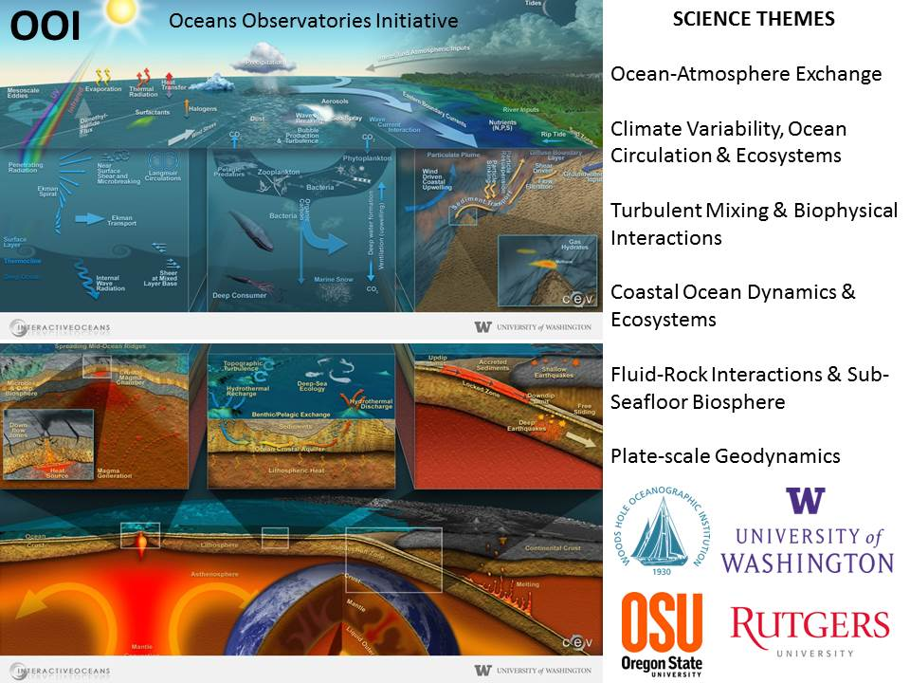

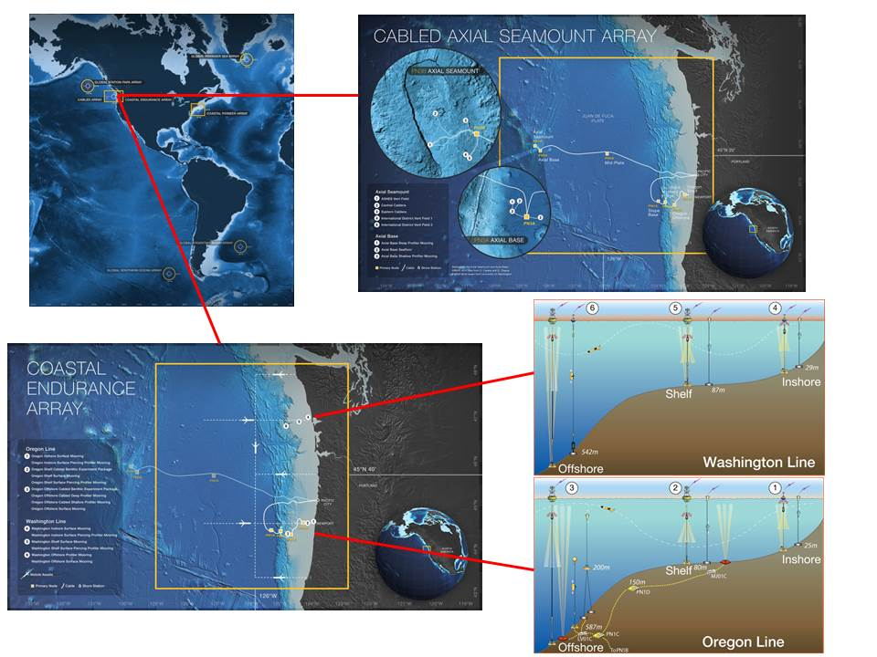

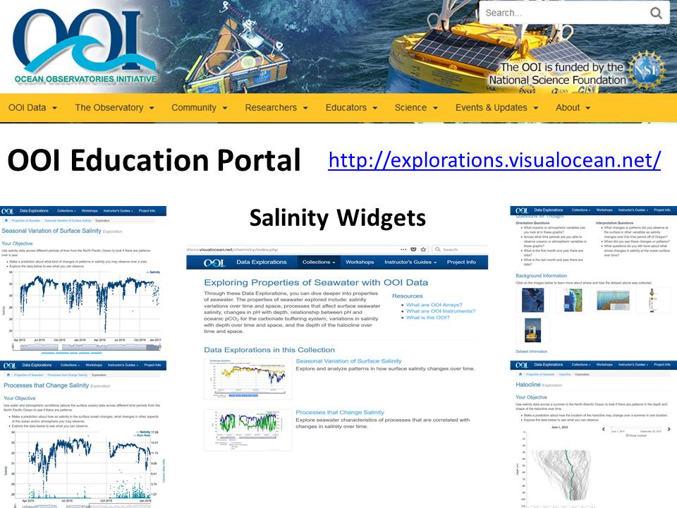

- Students do the following three OOI data explorations of salinity using the attached lab worksheet:
- Processes That Change Salinity - Students compare time series of air temperature, salinity, precipitation, evaporation, and rain rate at a coastal site in the Northern Pacific Ocean (Coastal Endurance Array) from April 2015 to December 2016 to explore the data for changes and patterns.
- Seasonal Variation of Surface Salinity - Students look at timeseries of single-point salinity over space and time to explore the data for changes and patterns. Students explore surface salinity data from the northern Pacific Ocean (Coastal Endurance Array) from April 2015 to March 2017 across different time periods to see if there are any seasonal variations. They then apply what they have learned by comparing patterns in salinity data across different time periods to determine if there are relationships over time across different regions of the ocean using data from the northern Pacific Ocean (Coastal Endurance Array), northern near polar Atlantic Ocean (Irminger Sea Array), northern Atlantic Ocean (Coastal Pioneer Array), and southern near polar Atlantic Ocean (Argentine Basin Array) from April 2015 to March 2016.
- Halocline - Students compare multiple salinity profiles over space to explore the data for changes and patterns in the location of the halocline over time. Students explore data from the northern Atlantic Ocean (Coastal Pioneer Array) from June through September 2015 across different parts of the summer. They then apply what they have learned by comparing patterns in halocline depth data during the summer to determine if there are relationships over time across different regions using data are from the northern temperate Atlantic Ocean (Coastal Pioneer Array) and northern near polar Atlantic Ocean (Irminger Sea Array) from June through September 2015.

Exploring Ocean Salinity using Oceans Observatories Initiative (OOI) data

PURPOSE: In lab this week, you will explore, using Oceans Observatories Initiative (OOI) data, the processes that change salinity and how salinity changes with season, location and depth.

PROCEDURE: You will be split into groups of two to make observations, brainstorm, and activate you prior knowledge of salinity, temperature and density. Then your group will work to explore data visualizations from the Salinity Collection on the Ocean Observatories Initiative (OOI) Data Explorations website (http://explorations.visualocean.net/chemistry/index.php).
EXPLORATION 1: PROCESSES THAT CHANGE SALINITY
Use the OOI Data Explorations to explore seawater characteristics of processes that are correlated with changes in salinity over time.
PROCEDURE: Use water and atmospheric conditions (above the surface ocean) data across different time periods from the North Pacific Ocean to see if there are patterns.
- Make a prediction about how as salinity in the surface ocean changes, what changes in other aspects of the ocean and/or atmosphere you may observe.
- Explore the data to see what you can observe.
- The url is: http://explorations.visualocean.net/chemistry/activity2.php?level=exploration

The questions below are intended to help you explore the interactive graphic. It’s important that you understand what and how the data are plotted.

- The parameters you can select on this graph are known as variables. Identify the oceanic and atmospheric variables you may use to compare with ocean salinity.

- How are each of these variables represented on the graph? That is, how can you differentiate between ocean salinity and the chosen parameter?

- The x-axis represents the time periods in which the data was collected. When was the data first collected and when was the data last collected? Give these answers in month and year.

- The data for this graph was taken from a location off the coast of Oregon. In general, how is salinity changing? How is this represented on the graph?

- How do the changes in salinity compare to the changes in the other variables? How are these changes represented on the graph?

Provide concise and complete answers to the following questions:
What months, during the year, do you see a general increase in salinity?

What months, during the year, do you see a general decrease in salinity?

From your observations, what variable(s) do you think has/have the greatest impact on salinity?

EXPLORATION 2: SEASONAL VARIATION OF SURFACE SALINITY
Use OOI Data Explorations to explore and analyze patterns in how surface salinity changes over time.
PROCEDURE: Use salinity data across different periods of time from the North Pacific Ocean to look if there are patterns over a year.
- Make a prediction about what kind of changes or patterns in salinity you may observe over a year.
- Explore the data below to see what you can observe.
- The url is: http://explorations.visualocean.net/chemistry/activity1.php?level=exploration
The data for this activity was obtained from a surface mooring located on the Washington continental shelf. View the “Background Information” near the bottom of the Explorations page to learn about the site location and how the data was obtained.
The questions below are intended to help you explore the interactive graphic. It’s important that you understand where and how the data plotted was collected and that you can correctly interpret the patterns.

The interactive graphic shows measured salinity from a surface mooring located on the Washington continental shelf over a period of time.

- What is the latitude and longitude of the mooring the data was obtained from?

- What type of instrument was used to obtain the data?

- What depth were these data obtained from?

- What variable is plotted on the x-axis?

- What variable is plotted on the y-axis?

- For which time periods was data not collected? Can you think of one possible reason for the missing data?

Provide concise and complete answers to the questions below.

During which month and year was the lowest salinity measured?

During which month and year was the highest salinity measured?

During which season do you see the largest range in measured salinity? Note the change in the salinity scale when you view the data by season.

Propose one possible explanation for why the range in measured salinity is largest during the season you selected in the question above.

It's time to apply what you've learned in the Explorations. Access the “Application” to view salinity data across different time periods to determine if there are relationships over time across different regions of the ocean (inshore vs. offshore, North Pacific versus North Atlantic, and near-polar versus temperate) and answer the questions below.

Which surface mooring location typically has the highest surface salinities during the summer months? Circle one.

Inshore or Offshore in the North Pacific Ocean?

Which surface mooring location typically has the highest surface salinities during the winter months? Circle one.

Inshore or Offshore in the North Pacific Ocean?

Which surface mooring location typically has the highest surface salinities? Circle one.

North Pacific Ocean or North Atlantic Ocean?

Northern near-polar or Southern temperate Atlantic Ocean?

Which surface mooring location typically has the highest range of surface salinities? Circle one.

Inshore or Offshore in the North Pacific Ocean?

North Pacific Ocean or North Atlantic Ocean?

Northern near-polar or Southern temperate Atlantic Ocean?

During which season is there the largest difference between surface waters salinities at the Inshore and Offshore mooring site? Give one reason why there is the biggest difference during this season.

Which ocean is the saltiest? Provide a possible explanation for your answer choice based on what you know about the processes that change salinity.

Why is there such little variation with season in surface water salinities in the Northern near-polar Ocean and Southern temperate Atlantic Ocean?

EXPLORATION 3: HALOCLINE
Use OOI Data Explorations to explore and analyze how surface salinity changes with depth over time.
PROCEDURE: Use salinity data across a summer in the North Atlantic Ocean to look if there are patterns in the depth and shape of the halocline over time.
- Make a prediction about how the location of the halocline may change over a summer in one location.
- Explore the data below to see what you can observe.
- The url is: http://explorations.visualocean.net/chemistry/activity6.php?level=exploration

This interactive graphic shows salinity from the Coastal Pioneer Array.

The questions below are intended to help you explore the interactive graphic. It’s important that you understand what and how the data are plotted.

- As you move the timeline slide, what happens to the date at the top of the graph?

- When was the data first collected and when was the data last collected? Give these answers in month and day.

- Salinity is measured in parts per thousand, essentially like a percent, but divided by 1000. What is the range of salinity indicated on the x-axis of each of the graphs? Be sure to look at each graph separately.

- Choose one day on the timeline slide. Generally, what happens to salinity as you go from the surface to the bottom of the profile?

- How does the profile change during the month of June? July? August? September?

- Make a statement about the changes in the halocline from June to September using your observations above.

It's time to apply what you've learned in the Explorations. Access the “Application” to view salinity data and determine if there are relationships in the depth and shape of the halocline over time between three different regions of the North Atlantic Ocean.

Provide a complete and concise answer to the questions below.

The depth is indicated on the y-axis. What are the deepest depths for each graph? Be sure to answer for each location separately.

The range of dates are located on the timeline slider. What are the beginning and end dates that the data is available?

Slide the date slider to June 21, 2015 (near Spring Solstice). Compare and contrast the three graphs. Give the similarities and differences of each graph. Repeat for 19 July, 2 August, 30 August, 13 September.

Ice Cube Challenge Experiment Worksheet
(Developed by the University of California Berkley)
Find two cups of water on the table. One is labeled “salt water,” the other is labeled “fresh water.” Both cups are room temperature.
Imagine that you added a scoop of ice in each cup. The water was not stirred or disturbed. What do you think would happen?
Quick Write: In which cup do you predict the ice will melt the fastest What makes you think that? Record your prediction and explain your reasoning. Once you record your ideas, discuss in your small group.

Now, do the experiment!
- Gently place a scoop of ice in each cup, and carefully observe what happens.
- Do not stir or disturb the water in the cups, or remove the ice during your observations.
- Check the ice cubes about every 30 seconds to observe the progress.
Describe what you notice as the ice cubes melt.

Which melted fastest after about 2-3 minutes?
Why do you think that happened?
After you have discussed with your group,
- Add a couple of drops of food coloring to each cup without disturbing the water in the cup.
- Compare what happens in each cup.
Does this help to explain the results? Explain what you and your group think is happening.

Read the explanation sheet handed out by your instructor.
Using Active Reading:
- Underline ideas that you think are interesting.
- Circle ideas that you think are confusing or unclear.
- Write questions in the margins.

Now, turn & talk with a partner.
- Share your understanding of the explanation.
- Try to answer one another’s questions.

Transforming STEM Teaching Faculty Learning Program
Students’ Explanations

Background for Ice Cube Activity
Ice melts faster in fresh water than in salt water.

It’s all about density!

1. What happens when ice melts in fresh water at room temperature?
– Water from melting ice is cold and fresh. It is more dense than fresh water at room temperature
(REMEMBER: Liquid water’s density decreases as temperature increases.)
– The denser cold water from the melting ice sinks to the bottom of the cup. That’s why you saw the food coloring sink to the bottom of the cup.
– When the dense cold water sinks to the bottom of the cup, it displaces water at the bottom of the cup. The room-temperature water at the bottom of the cup has to go somewhere when it is pushed out of the way by the sinking cold water. The displaced room-temperature water from the bottom of
the cup moves up toward the surface. You saw that the food coloring was eventually mixed throughout the cup just by the movement of dense cold water sinking and room-temperature water being displaced.
– The result of this mixing process is that the ice is always being surrounded by new room-temperature water as the dense cold water sinks and less dense room-temperature water is pushed upward. Therefore, ice melts faster in fresh water.

2. What happens when ice melts in salt water at room temperature?
– Water from melting ice is cold and fresh. Fresh water is always less dense than salt water no matter what the water temperature is. (REMEMBER: Water density decreases as salinity decreases.)
– Since the cold water from the melting ice is less dense than the salt water, it floats on the top of the salt water. That’s why you saw the food coloring form a layer at the top of the cup.
– The layer of cold water from the melting ice “insulates” the ice. In other words, the cold, fresh water from the melting ice helps keep the ice cold. Therefore, the ice melts more slowly in salt water.
