Jigsaw Piece #1 – Temperature
The data below comes from OOI Global Irminger Sea array in the sub-polar North Atlantic. Note the different colored lines come from nearby sensors at the same location, but you can interpret them as all representing measurements of the same water in the surface mixed layer.
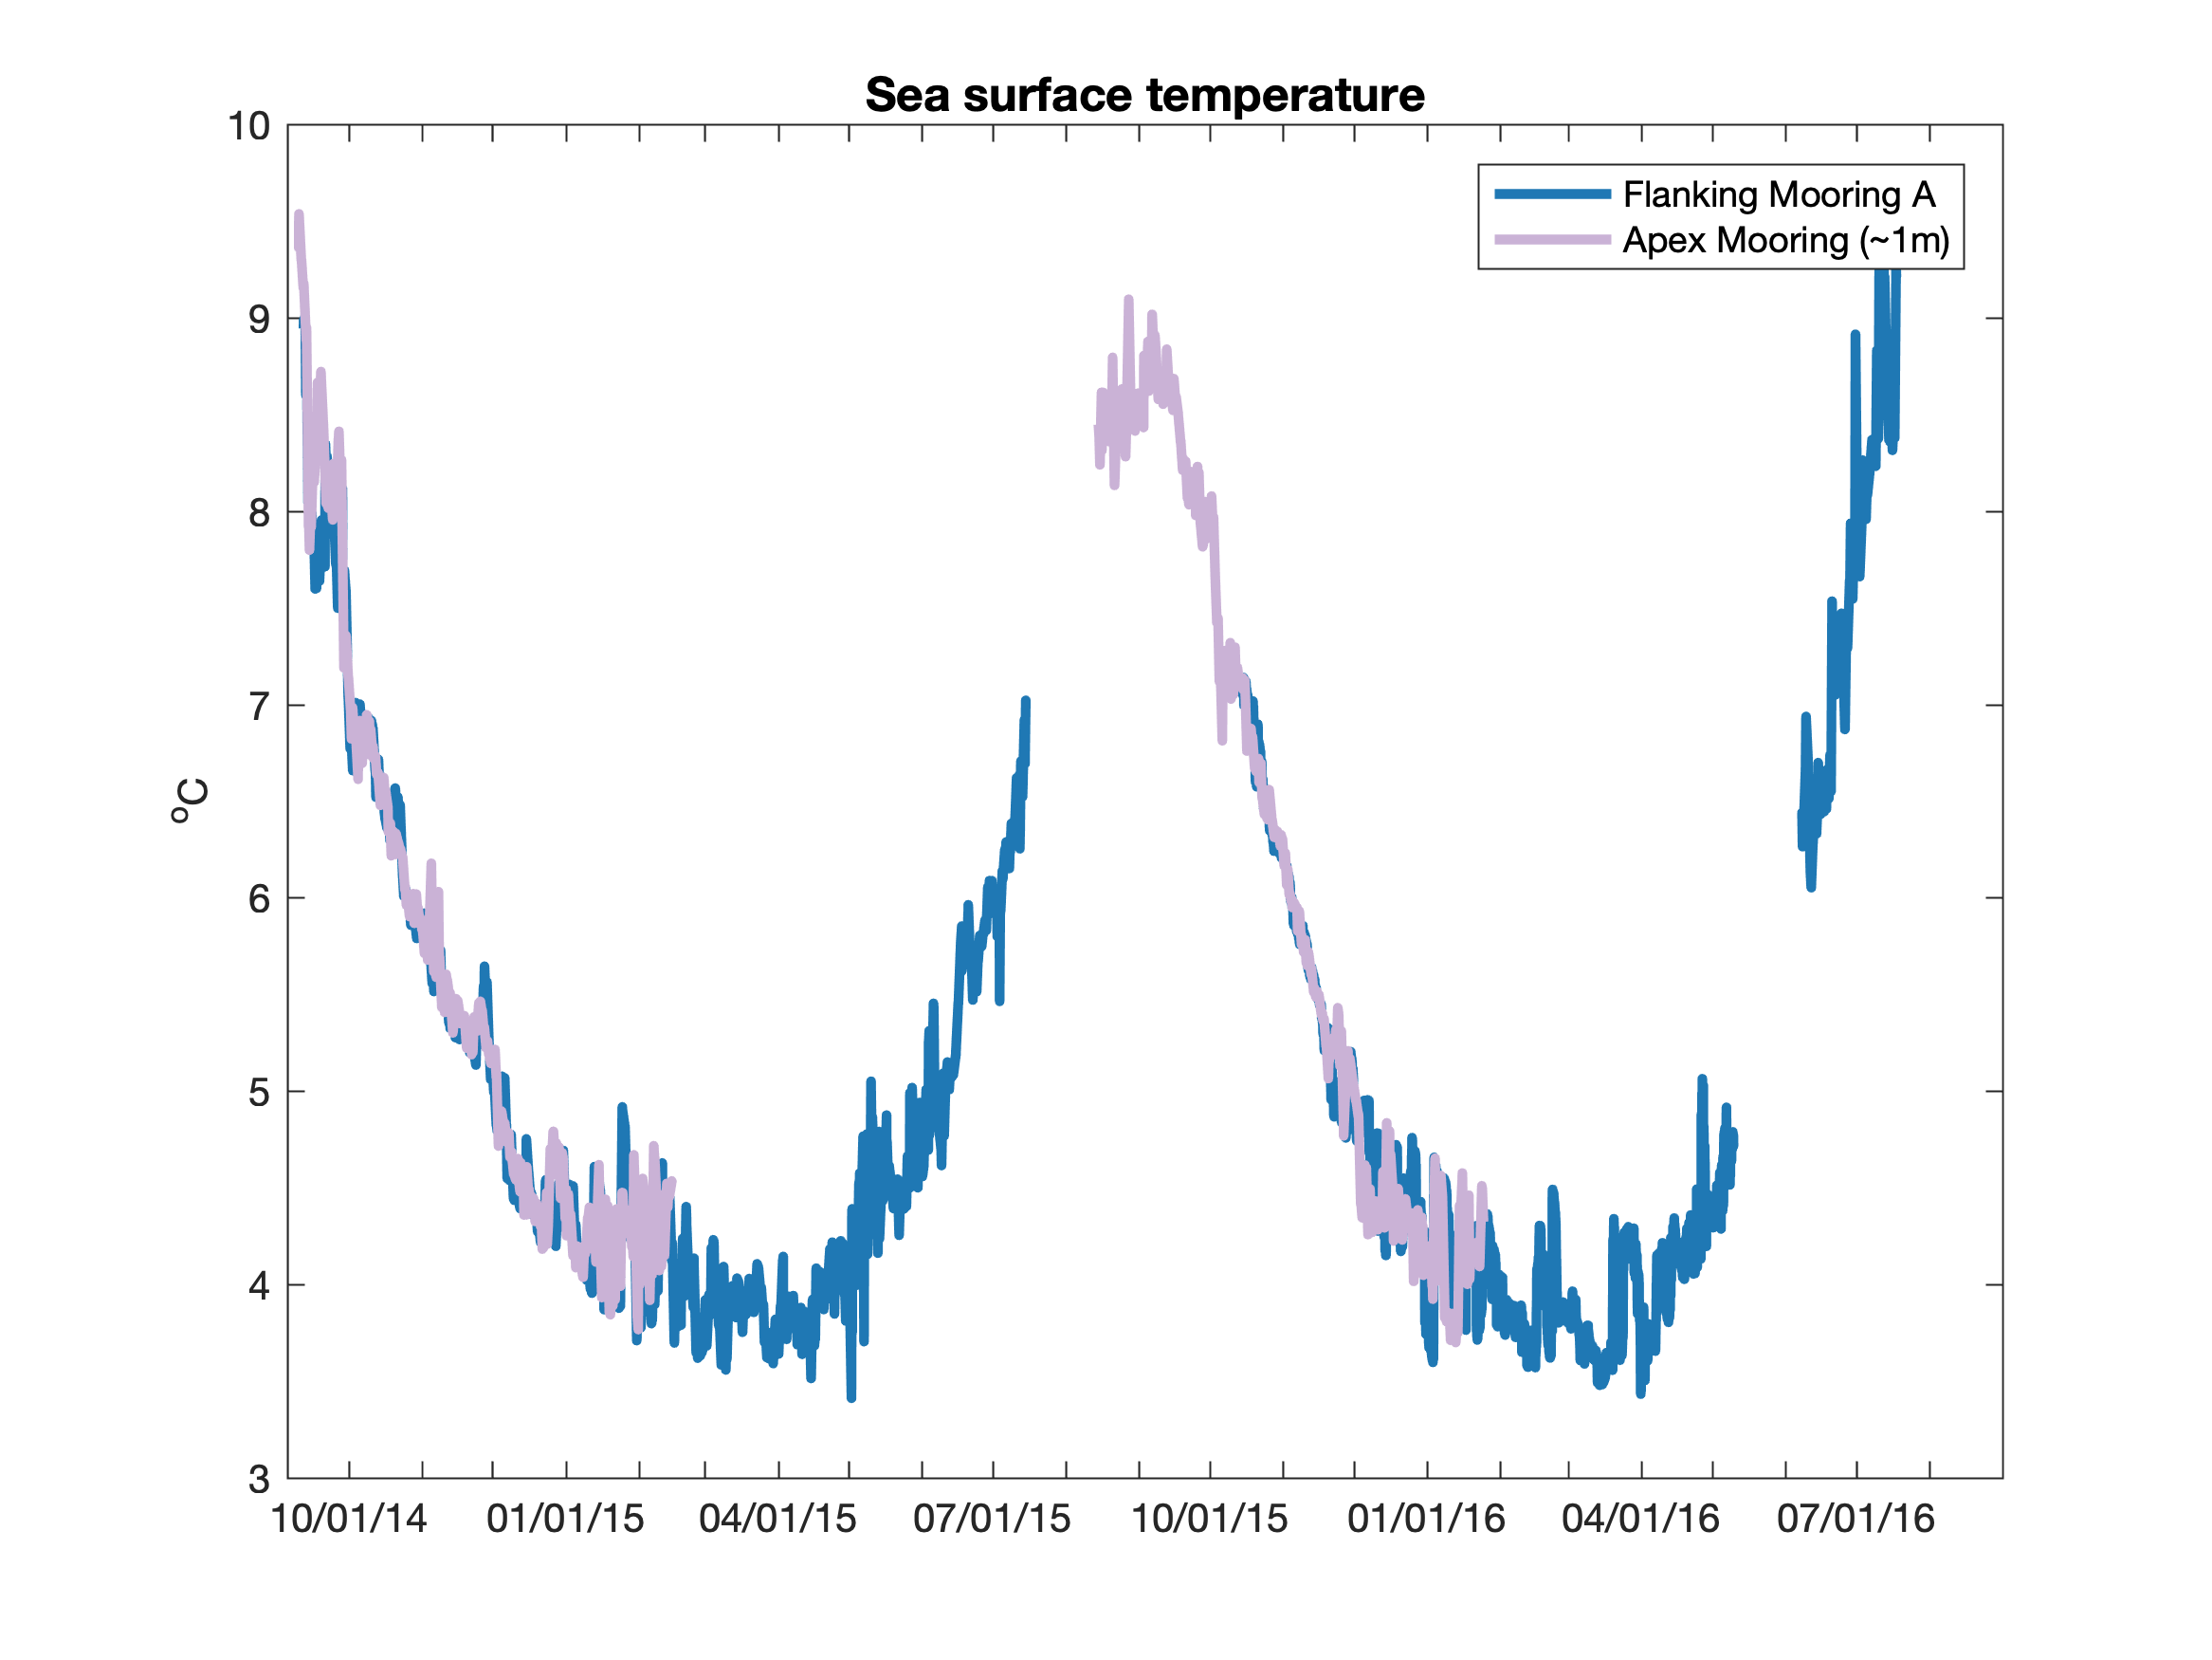

Describe the pattern(s) or other significant features you see in this dataset?

Key feature is seasonal cycle, with maximum sea surface temperature at the end of summer (~August-September) and minimum sea surface temperature at the end of winter (~March-April).

Based on your prior oceanographic knowledge, what do you think is causing these patterns?

The surface ocean loses heat to the atmosphere during the winter (due to cold air temperatures and wind-driven mixing) and gains heat from the atmosphere during summer (due to warmer air temperatures, increased solar radiation, and low winds that maintain strong stratification – i.e. a shallow surface mixed layer that can warm up more quickly than a deeper mixed layer).

Jigsaw Piece #2 – Salinity
The data below comes from OOI Global Irminger Sea array in the sub-polar North Atlantic. Note the different colored lines come from nearby sensors at the same location, but you can interpret them as all representing measurements of the same water in the surface mixed layer.
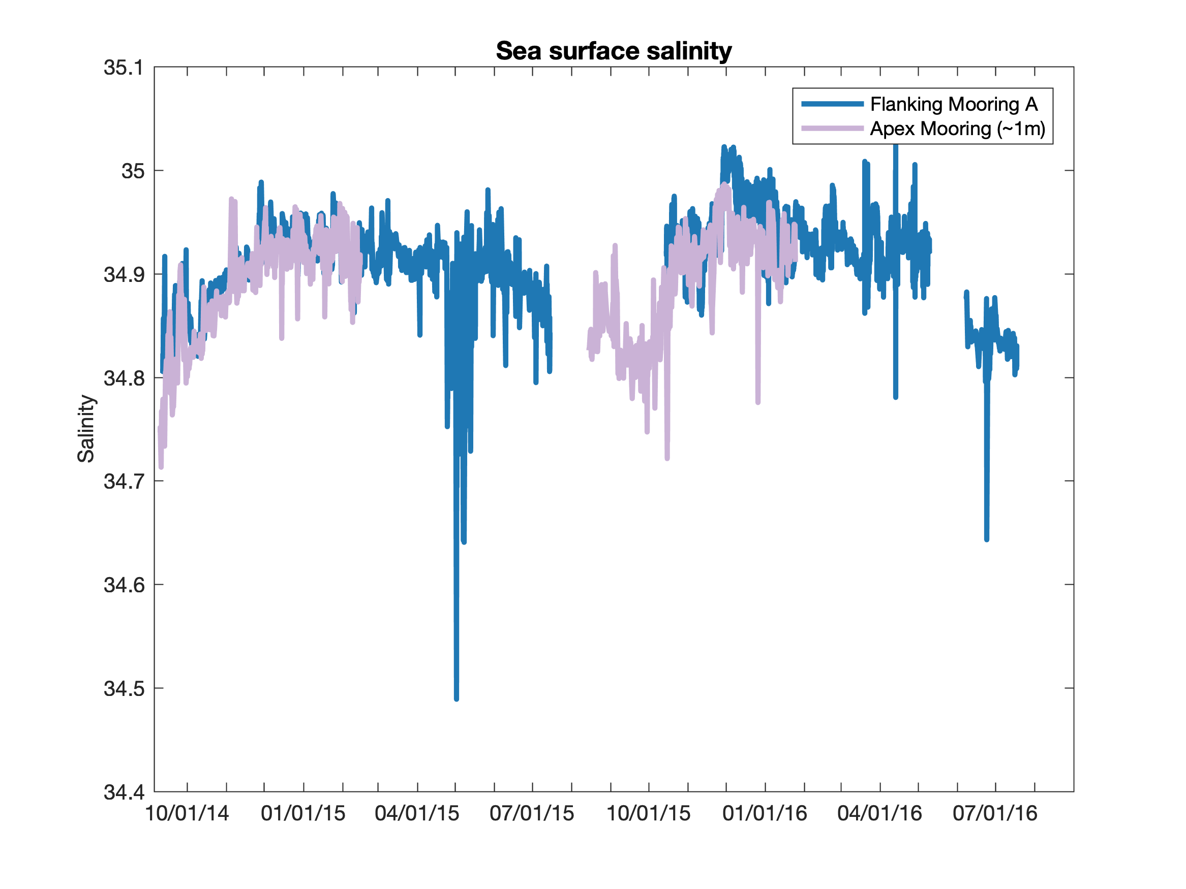Describe the pattern(s) or other significant features you see in this dataset?

Based on your prior oceanographic knowledge, what do you think is causing these patterns?

Jigsaw Piece #3 – Chlorophyll
The data below comes from OOI Global Irminger Sea array in the sub-polar North Atlantic. Note the different colored lines come from nearby sensors at the same location, but you can interpret them as all representing measurements of the same water in the surface mixed layer.
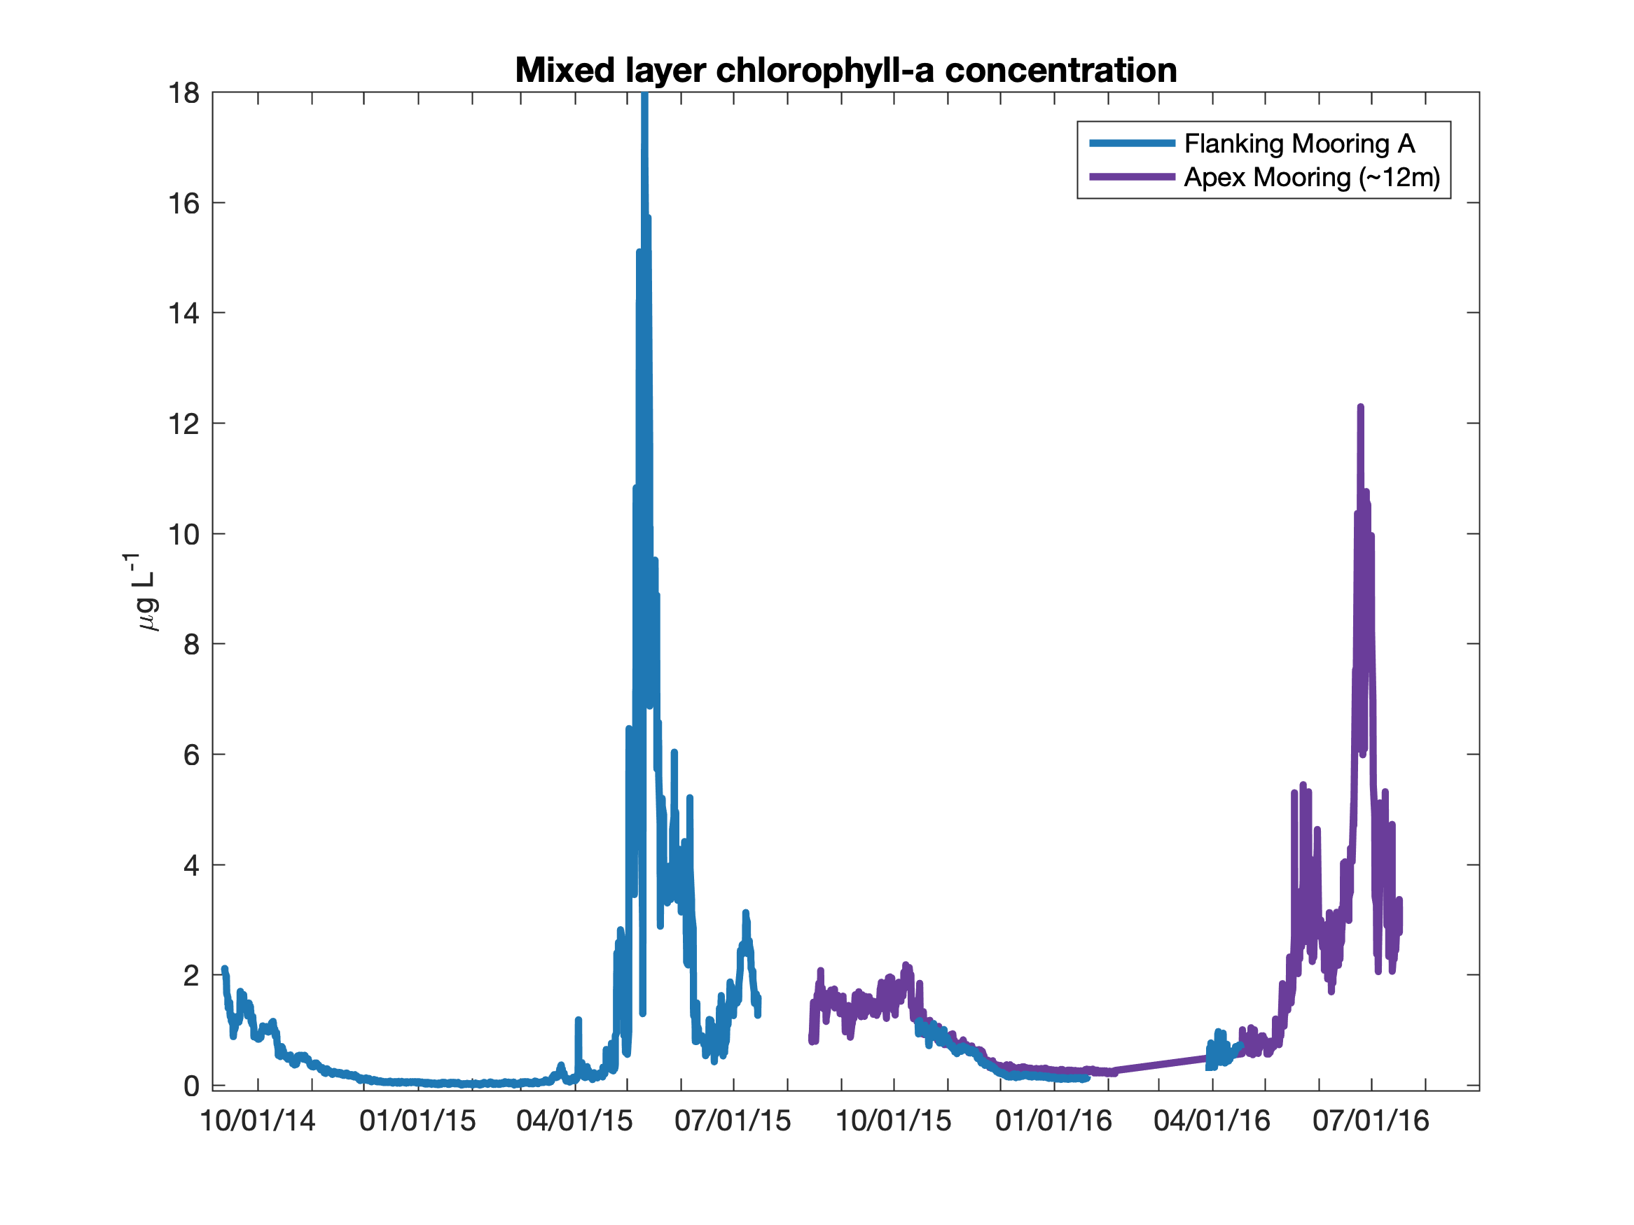
Describe the pattern(s) or other significant features you see in this dataset?

Key feature is the seasonal cycle of chlorophyll concentrations, which are very low in winter, begin to increase in April-May, and reach a maximum in June before decreasing in late summer (though remaining above winter levels through September-October).

Based on your prior oceanographic knowledge, what do you think is causing these patterns?

This seasonal cycle in chlorophyll (the photosynthetic pigment found in phytoplankton) indicates changes in the biomass of phytoplankton in the surface ocean. The increase in spring is the result of the spring bloom, where photosynthesis rates increase and phytoplankton growth is faster than the rate of grazing, leading to an increase in biomass.

Jigsaw Piece #4 – Dissolved Oxygen
The data below comes from OOI Global Irminger Sea array in the sub-polar North Atlantic. Note the different colored lines come from nearby sensors at the same location, but you can interpret them as all representing measurements of the same water in the surface mixed layer.
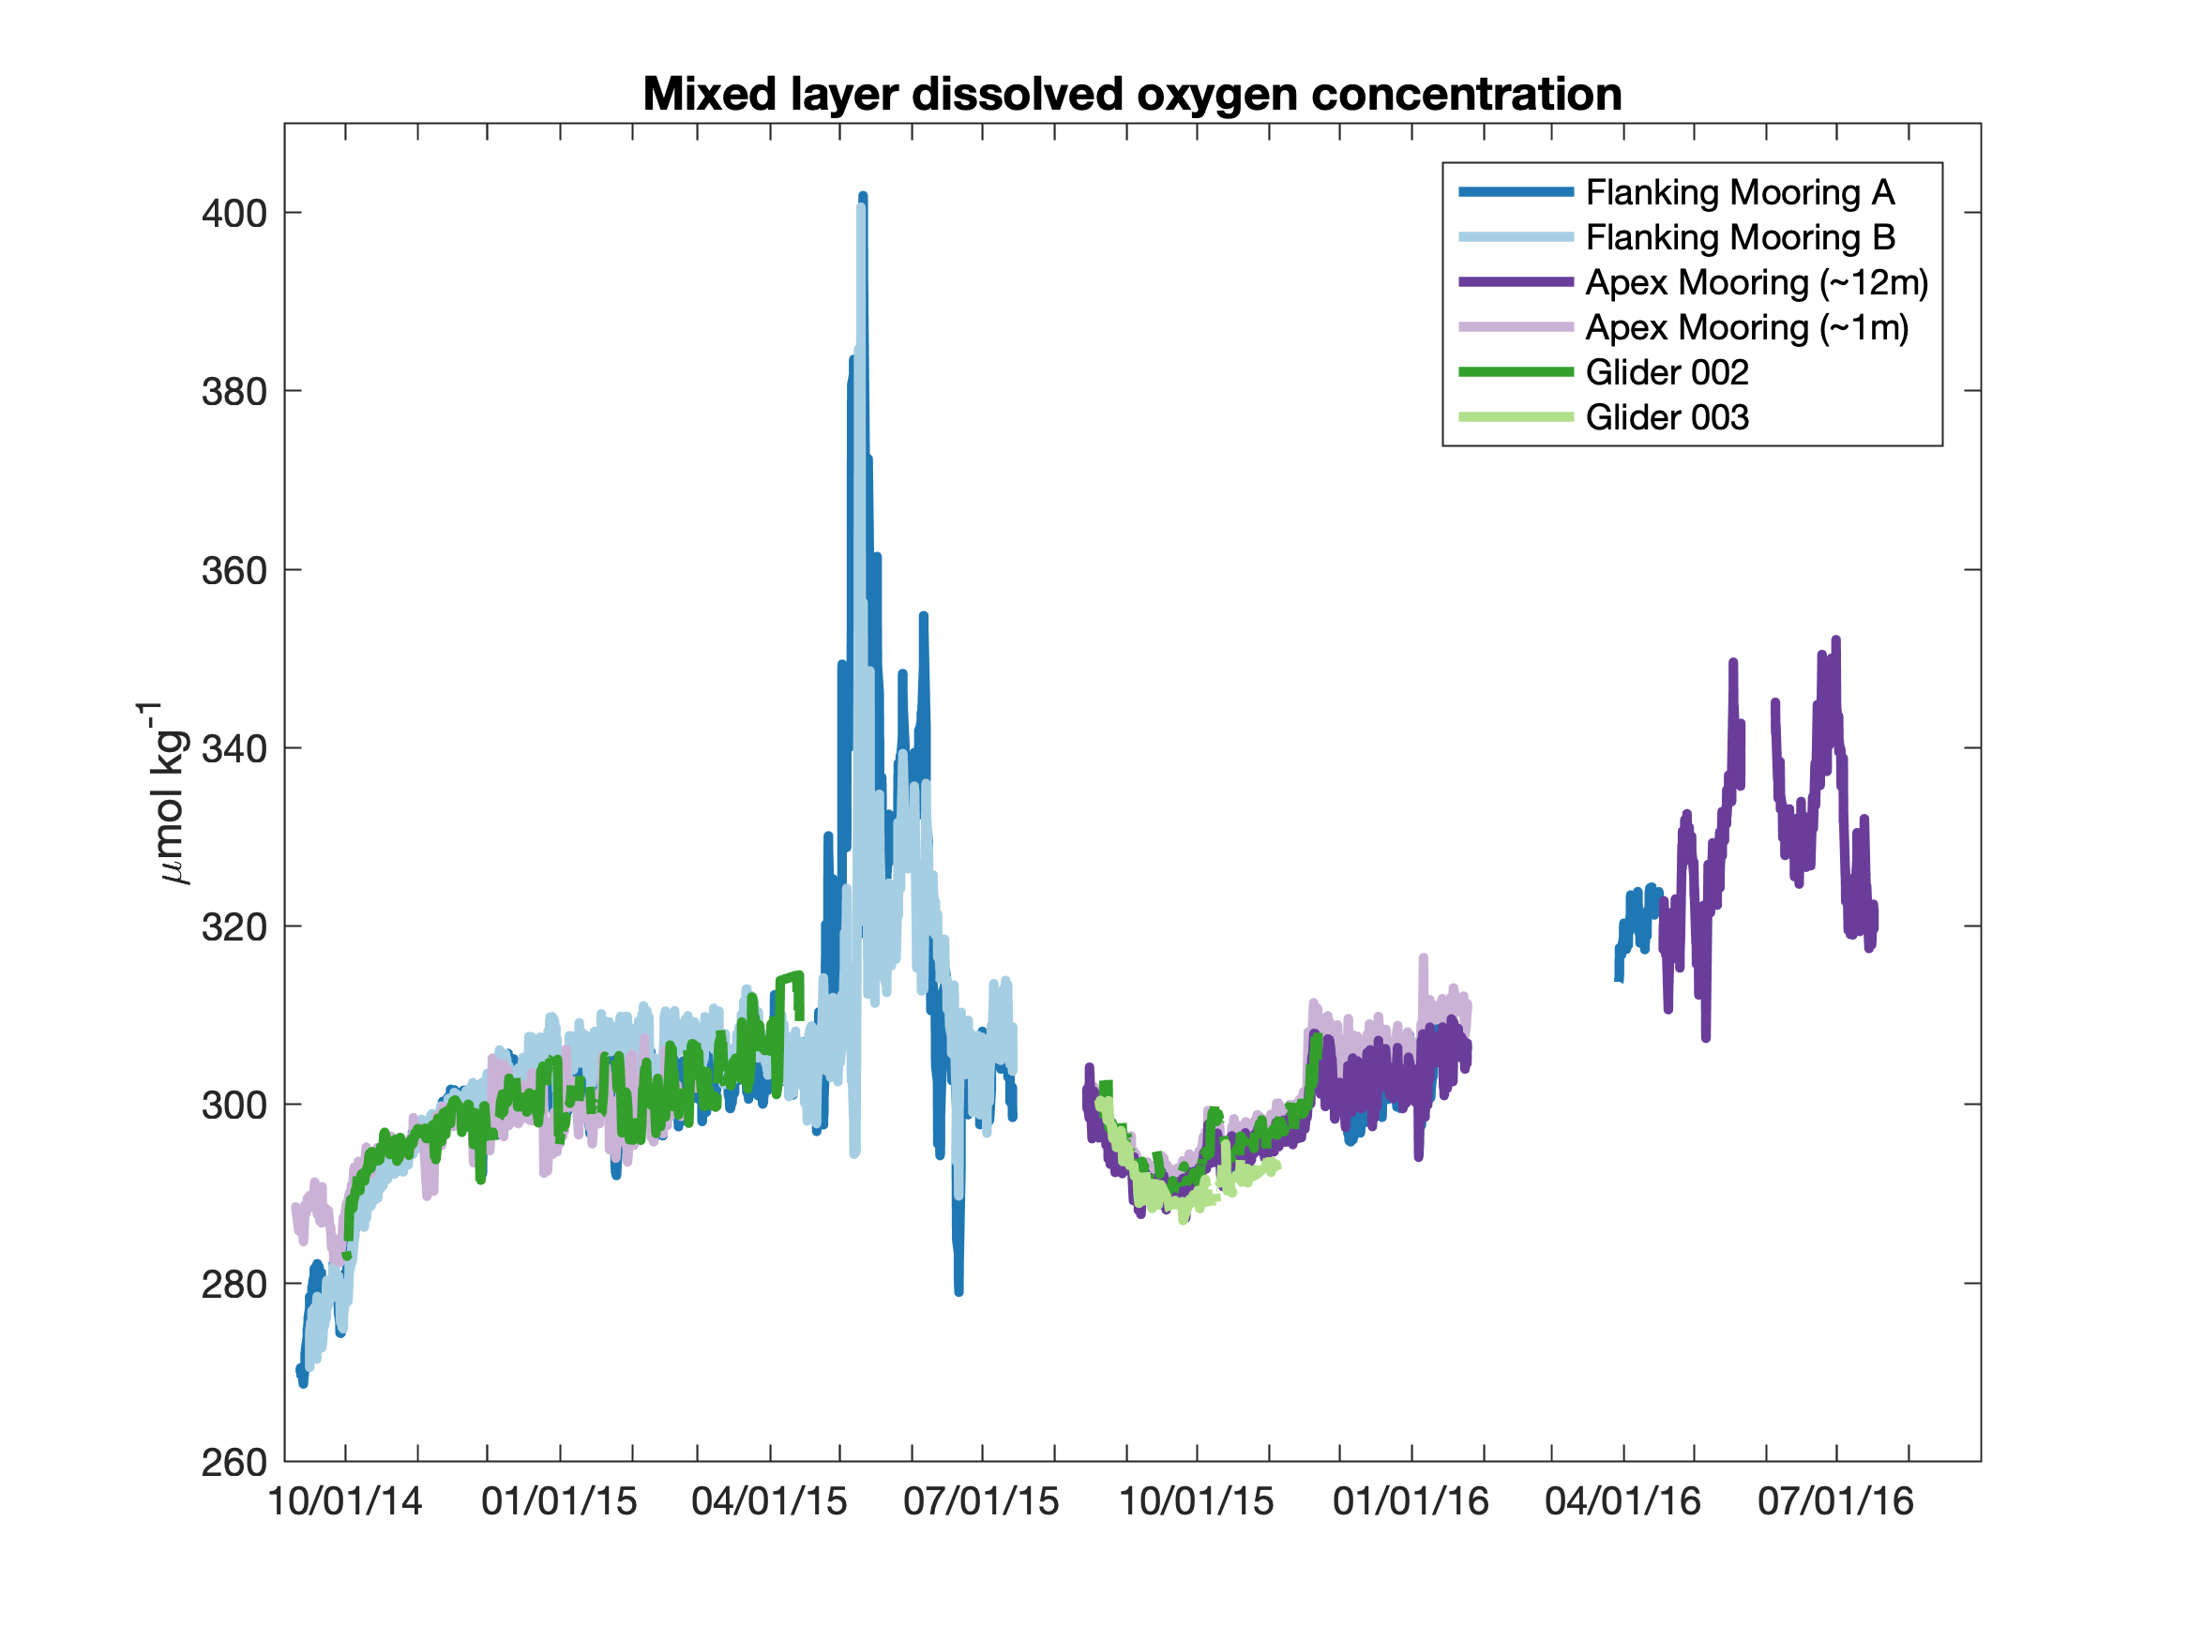
Describe the pattern(s) or other significant features you see in this dataset?

Oxygen concentrations are lowest in early fall (~October), increase slowly through the winter, and then have a large and rapid increase in spring (May-June), though the magnitude of this increase is greater in 2015 than in 2016.

Based on your prior oceanographic knowledge, what do you think is causing these patterns?

Oxygen concentrations are affected here by two processes: 1) temperature-driven changes in the solubility of dissolved gases in water, which leads to lower oxygen concentrations when waters are warm and higher oxygen concentrations when waters are cold, and 2) biology, where photosynthesis increases dissolved oxygen concentrations and respiration reduces dissolved oxygen concentrations. The rapid increase in oxygen in spring is due to net photosynthesis during the spring bloom.

Bringing it Together…
1. Now compare the 4 datasets and the patterns and features observed in each. What connections can you make between the datasets and observed patterns to describe the seasonal cycle of productivity at the Irminger Sea OOI site?

As the sea surface temperature warms following its end-of-winter minimum in March-April, chlorophyll and dissolved oxygen concentrations increase rapidly and in concert during May-June. This is evidence of the classic North Atlantic spring bloom, where the rising sea surface temperatures are evidence of enhanced stratification and greater solar insolation, which increase light availability in the surface mixed layer (instructor note: making this connection requires prior student knowledge). Chlorophyll and dissolved oxygen concentrations increase together at the start of the bloom because both are the result of enhanced photosynthesis rates, leading to phytoplankton growth that outstrips grazing and mortality pressure.

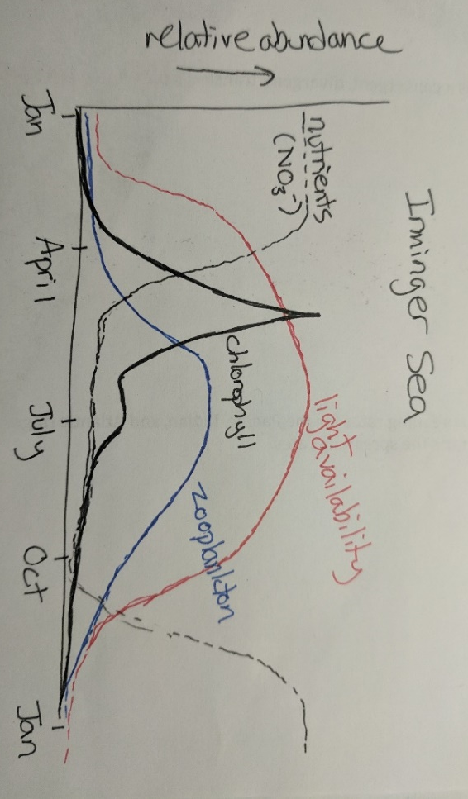
2. Based on the seasonal cycles in the variables that were directly measured and your understanding of the controls on productivity in this region, we can begin to infer the seasonal cycle in properties that were not directly measured. Draw schematic plots that illustrates your hypothesized seasonal cycle at the Irminger Sea OOI site for: 1) light availability, 2) nitrate concentrations, and 3) zooplankton abundance.

Key features:
- Light availability is low in winter and high in summer (strong seasonal cycle due to high latitude location and stratification in spring-summer). Light availability increases prior to the springtime increase in chlorophyll.
- Nitrate (nutrient) concentrations are high in winter and then decrease when chlorophyll begins to increase in spring (since net photosynthesis will use up nutrients). Nitrate concentrations increase in winter when sea surface temperature cool, indicating mixing with deeper waters.
- Zooplankton abundance increases in spring-summer with its peak coming later than the peak in chlorophyll. The increase in zooplankton provides grazing pressure that reduces the chlorophyll at the end of the spring bloom.
Let’s take another look at the dissolved oxygen dataset… Compare the observed oxygen concentration (all the colored lines) to the equilibrium value (shown in black), expected if there were no influence of photosynthesis or respiration.
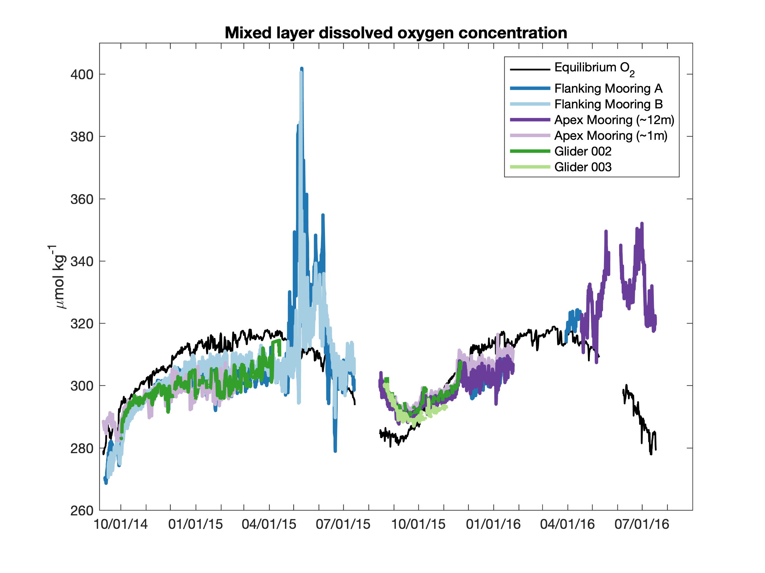
3. During what time of year does the oxygen concentration indicate that the rate of photosynthesis exceeds the rate of respiration?
Photosynthesis exceeds respiration at all times that the measured oxygen (colored lines) is greater than the equilibrium concentration (black line) – i.e. from mid-April through the end of September. Instructor note: a common misconception is that the oxygen decrease in June is a result of net respiration, but actually is just the result of lower-magnitude net photosynthesis.

4. In the second phase of the spring bloom, both chlorophyll and oxygen concentrations decreased from their maximum values. What processes led these concentrations to decrease?
Grazing by zooplankton and mortality decrease the phytoplankton biomass (and therefore the chlorophyll concentration). Oxygen decreases as the rates of photosynthesis and respiration come closer into balance later in the bloom, and as oxygen outgasses to the atmosphere (which happens because it is supersaturated – i.e. greater concentration than equilibrium).

The data used in this activity was adapted from Palevsky, H.I., and D.P. Nicholson. 2018. The North Atlantic biological pump: Insights from the Ocean Observatories Initiative Irminger Sea Array. Oceanography 31(1):42–49, https://doi.org/10.5670/oceanog.2018.108.

