Jigsaw Piece #1 – Temperature
The data below comes from OOI Global Irminger Sea array in the sub-polar North Atlantic. Note the different colored lines come from nearby sensors at the same location, but you can interpret them as all representing measurements of the same water in the surface mixed layer.
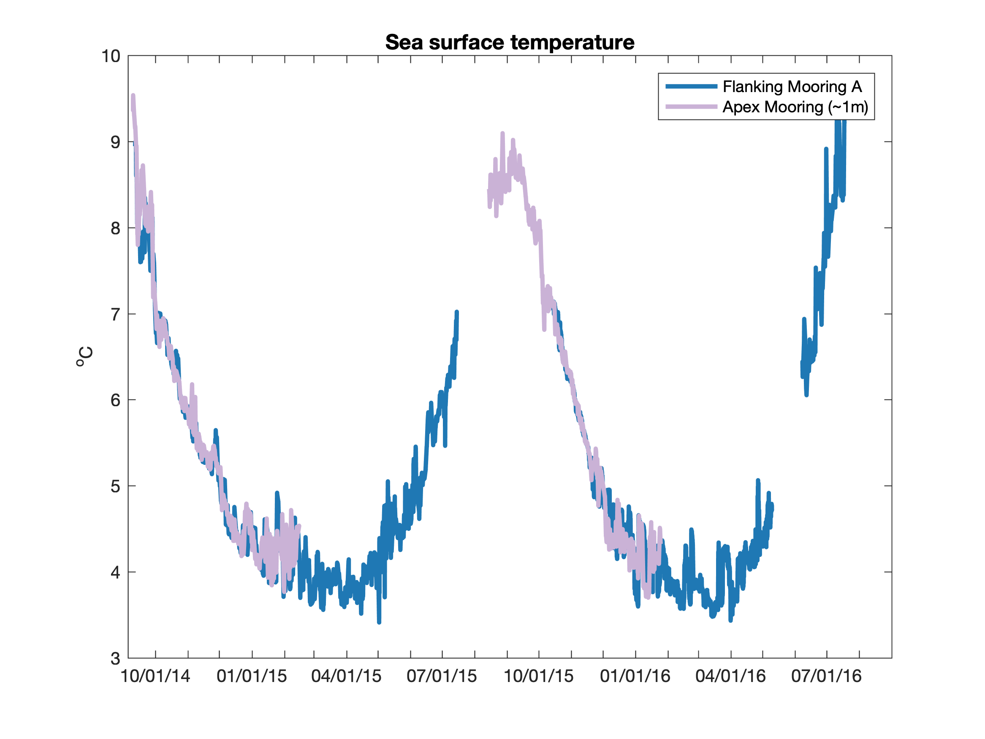

Describe the pattern(s) or other significant features you see in this dataset?

Based on your prior oceanographic knowledge, what do you think is causing these patterns?

Jigsaw Piece #2 – Salinity
The data below comes from OOI Global Irminger Sea array in the sub-polar North Atlantic. Note the different colored lines come from nearby sensors at the same location, but you can interpret them as all representing measurements of the same water in the surface mixed layer.
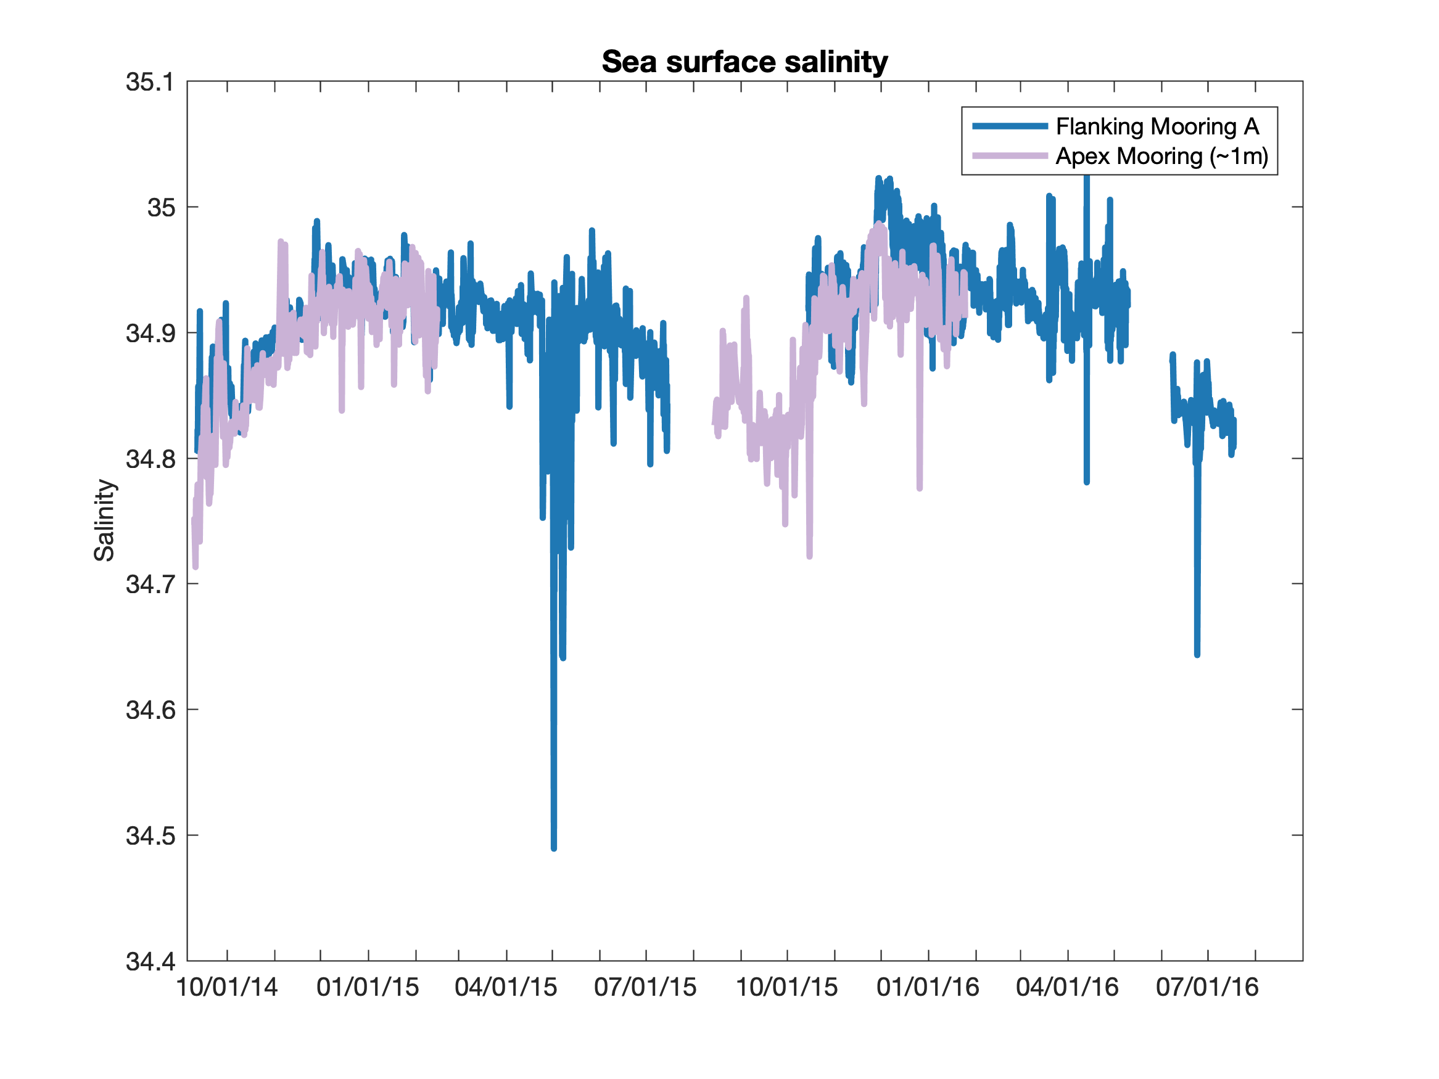Describe the pattern(s) or other significant features you see in this dataset?

Based on your prior oceanographic knowledge, what do you think is causing these patterns?

Jigsaw Piece #3 – Chlorophyll
The data below comes from OOI Global Irminger Sea array in the sub-polar North Atlantic. Note the different colored lines come from nearby sensors at the same location, but you can interpret them as all representing measurements of the same water in the surface mixed layer.
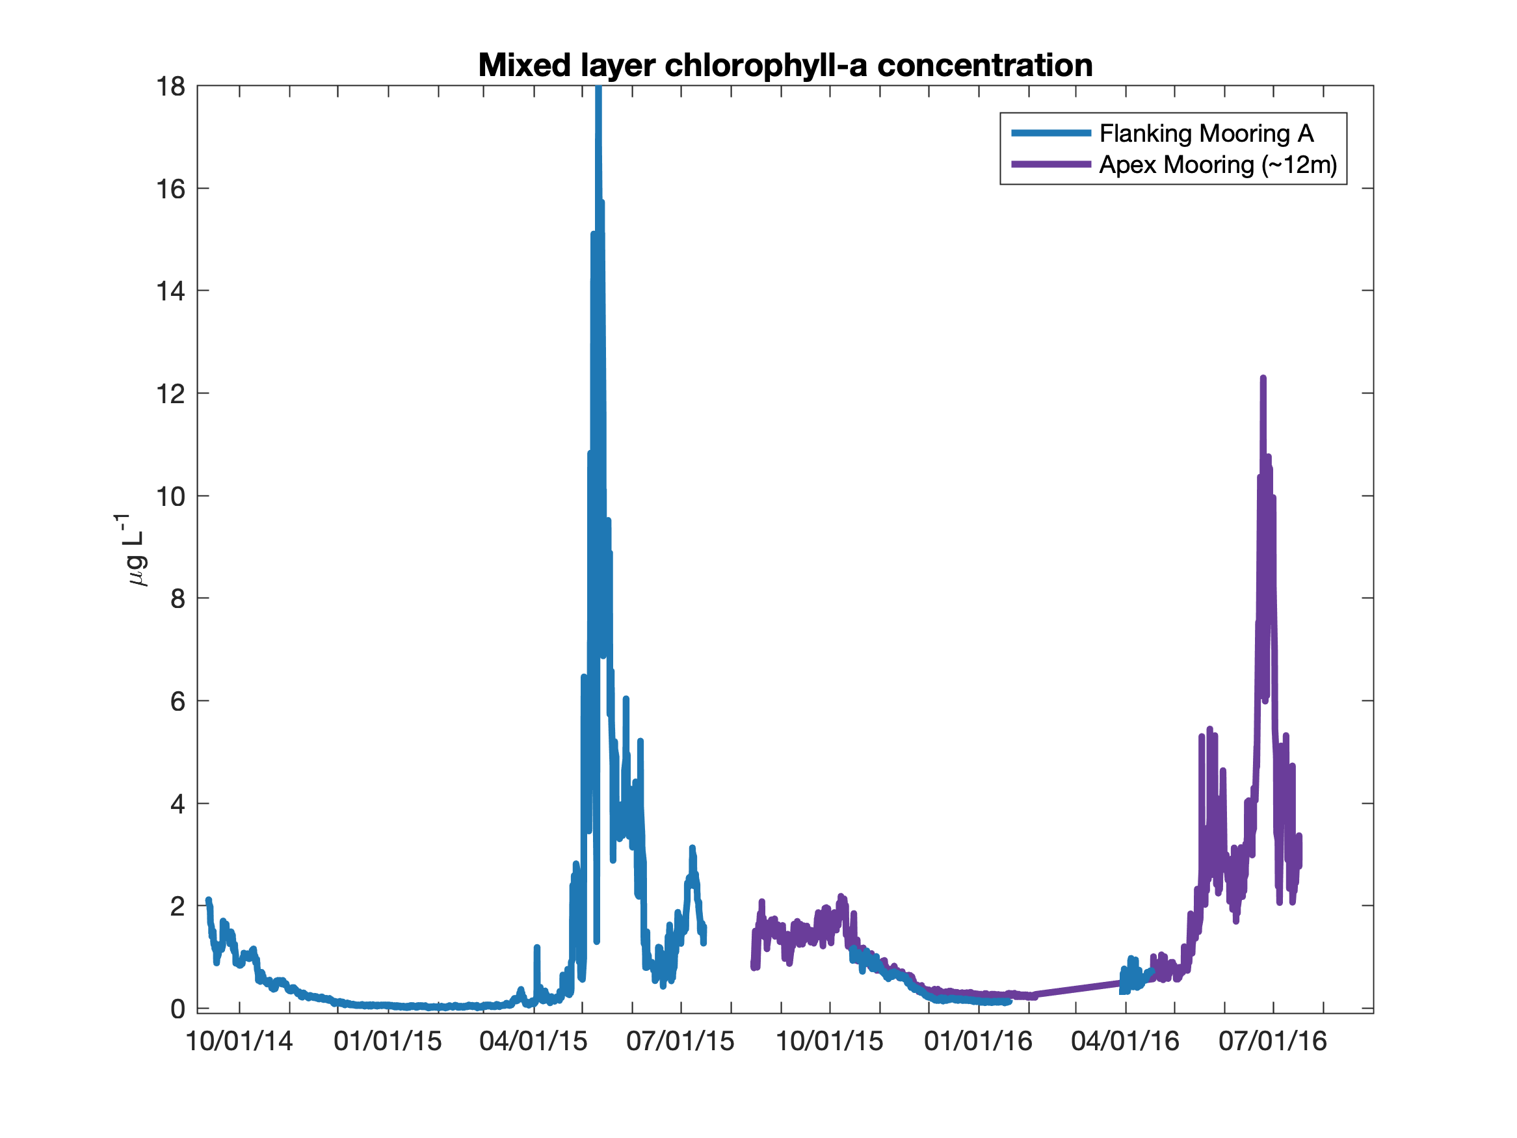

Describe the pattern(s) or other significant features you see in this dataset?

Based on your prior oceanographic knowledge, what do you think is causing these patterns?

Jigsaw Piece #4 – Dissolved Oxygen
The data below comes from OOI Global Irminger Sea array in the sub-polar North Atlantic. Note the different colored lines come from nearby sensors at the same location, but you can interpret them as all representing measurements of the same water in the surface mixed layer.
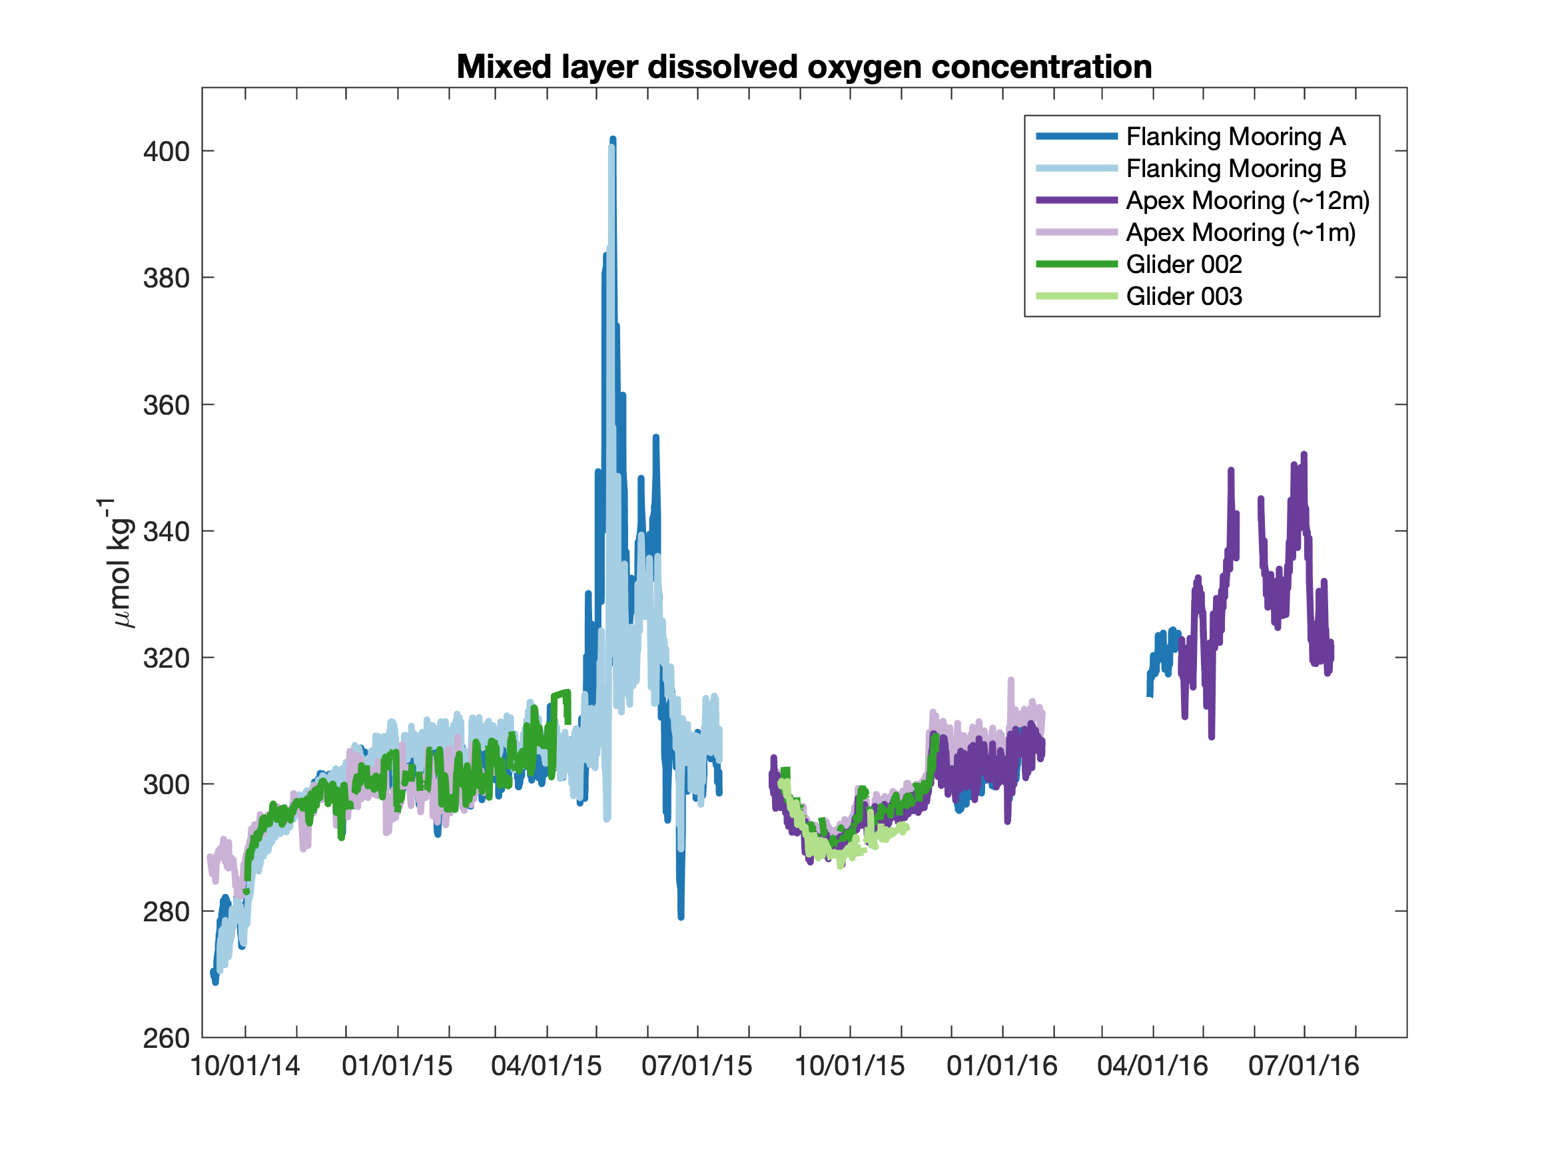

Describe the pattern(s) or other significant features you see in this dataset?

Based on your prior oceanographic knowledge, what do you think is causing these patterns?

Bringing it Together…
1. Now compare the 4 datasets and the patterns and features observed in each. What connections can you make between the datasets and observed patterns to describe the seasonal cycle of productivity at the Irminger Sea OOI site?

2. Draw a schematic plot that shows the seasonal cycle of the phytoplankton biomass alongside your estimate of what you would expect for the limiting nutrient(s) concentrations, light availability, and zooplankton abundance.

Let’s take another look at the dissolved oxygen dataset… Compare the observed oxygen concentration (all the colored lines) to the equilibrium value (shown in black), expected if there were no influence of photosynthesis or respiration.
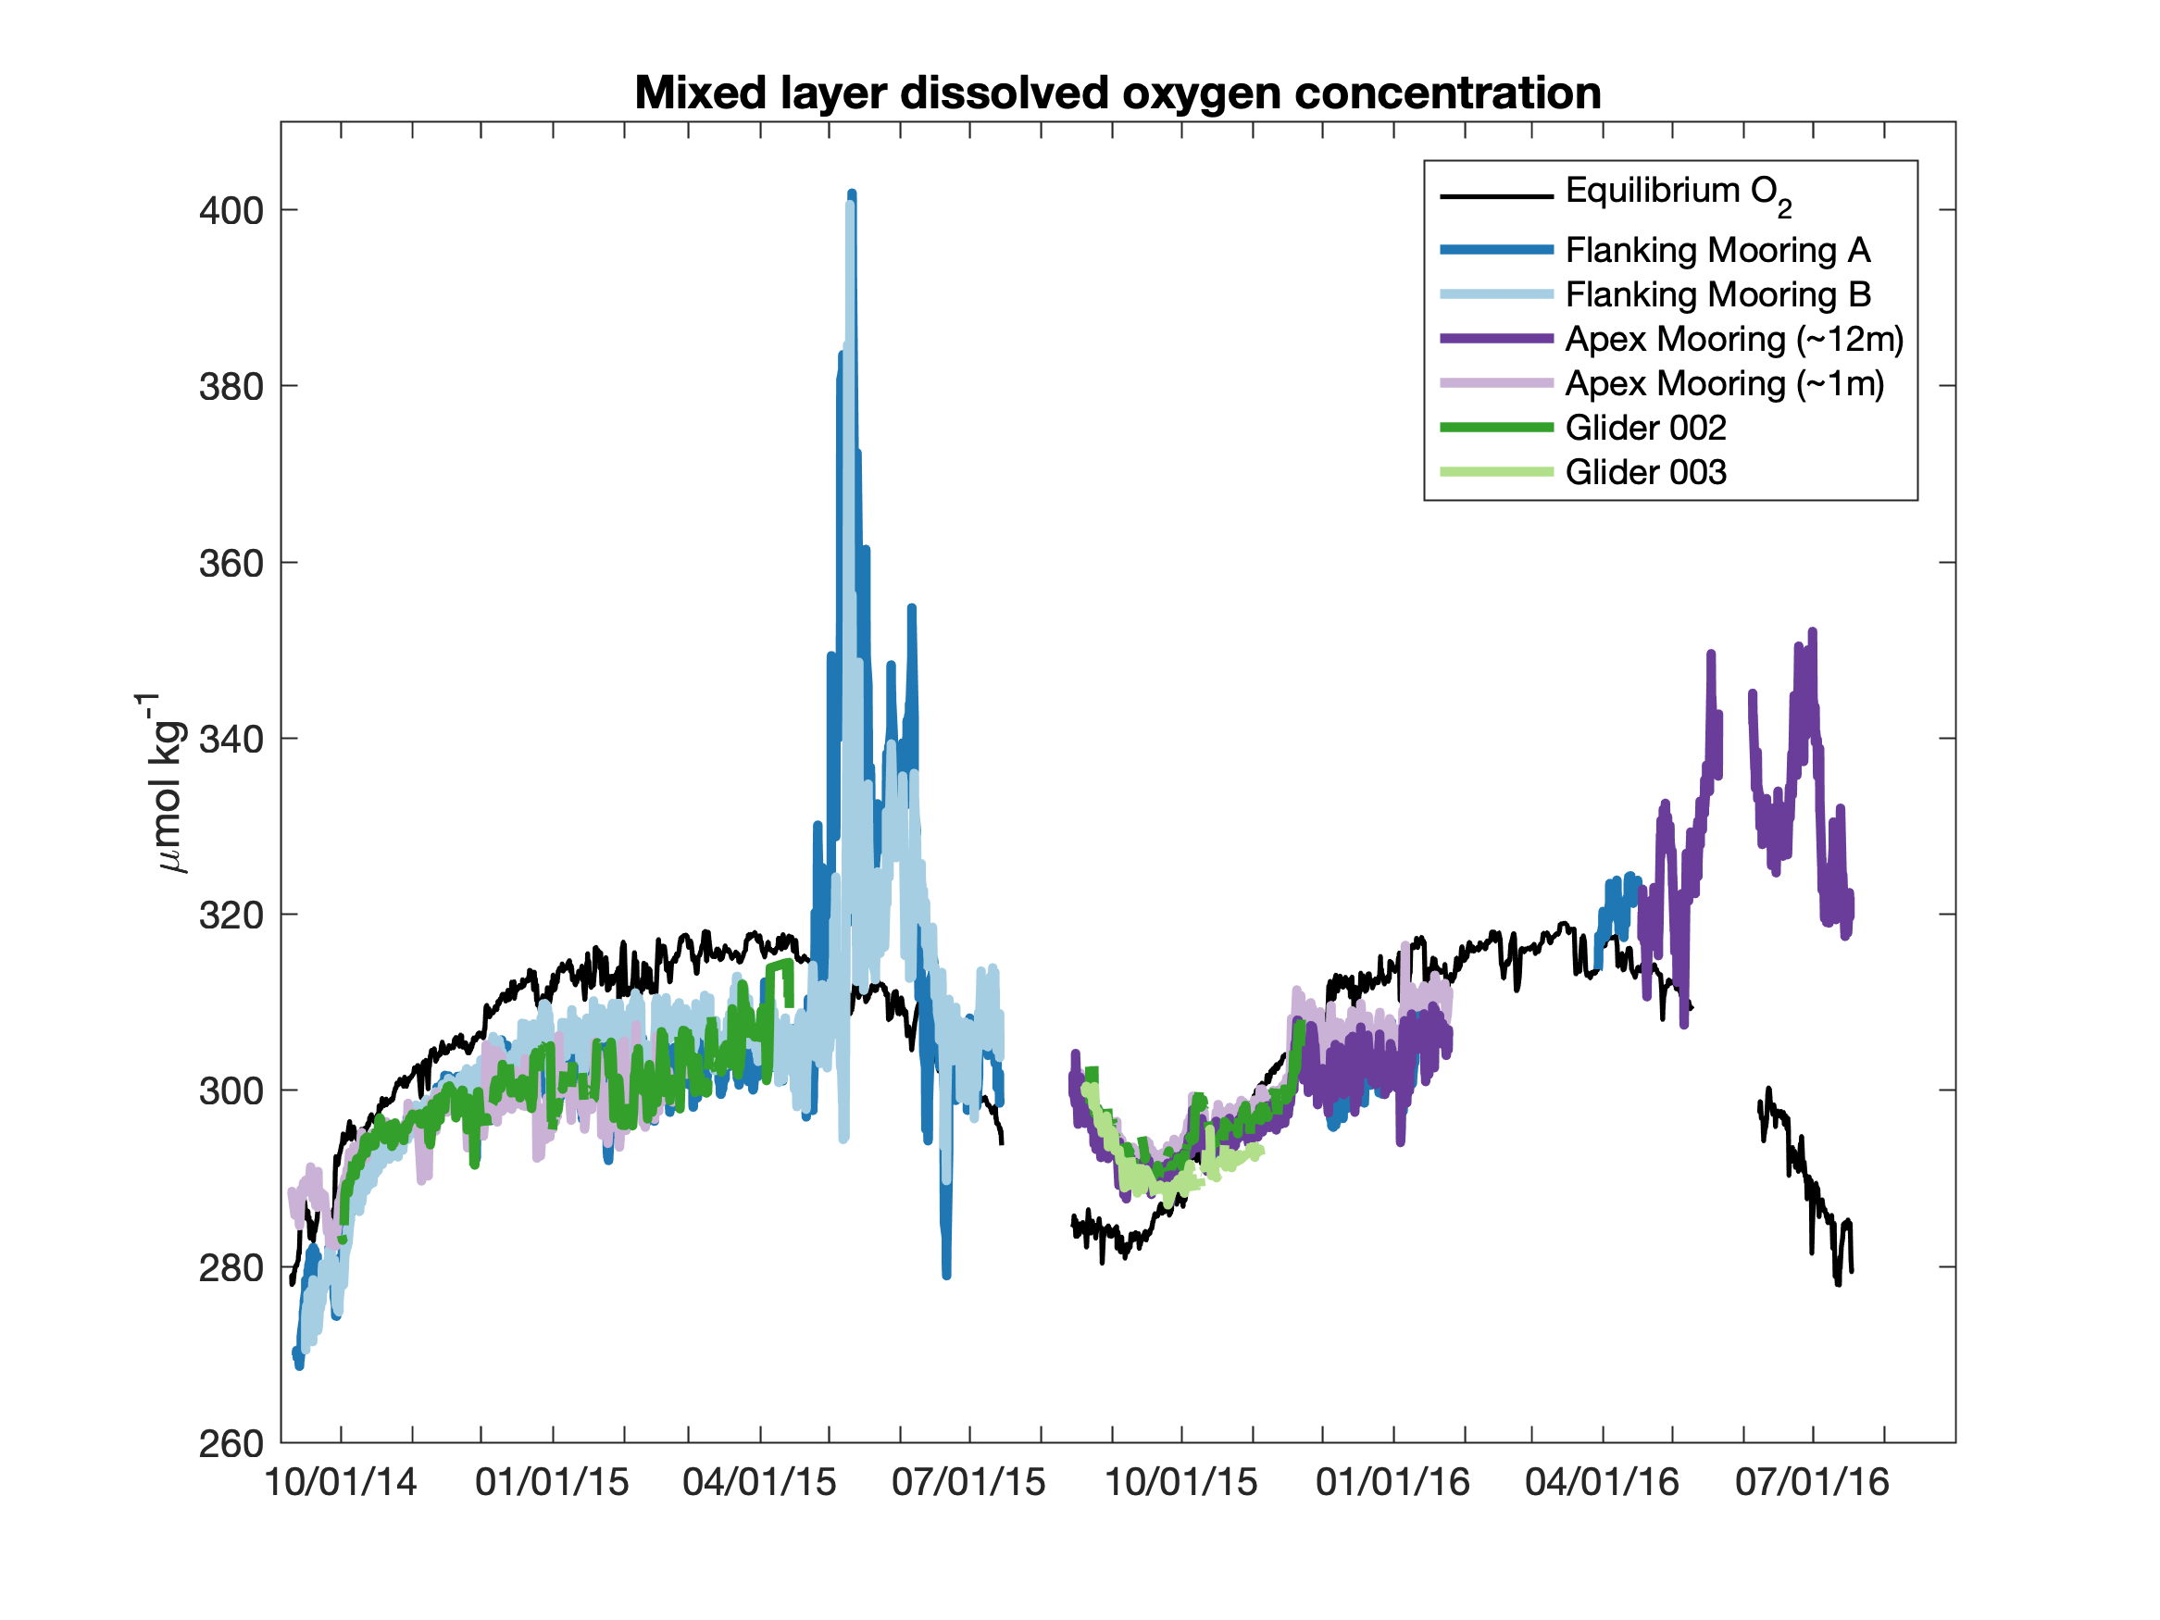

3. During what time of year does the oxygen concentration indicate that the rate of photosynthesis exceeds the rate of respiration?

4. In the second phase of the spring bloom, both chlorophyll and oxygen concentrations decreased from their maximum values. What processes led these concentrations to decrease?

Special thanks to H. Palevsky for providing the data used in this activity, which was adapted from Palevsky, H.I., and D.P. Nicholson. 2018. The North Atlantic biological pump: Insights from the Ocean Observatories Initiative Irminger Sea Array. Oceanography 31(1):42–49, https://doi.org/10.5670/oceanog.2018.108.

